KZN Feedback:
We are now testing like with active using it with my friend
So the names should pop-up for example after META - (Subcription plan)
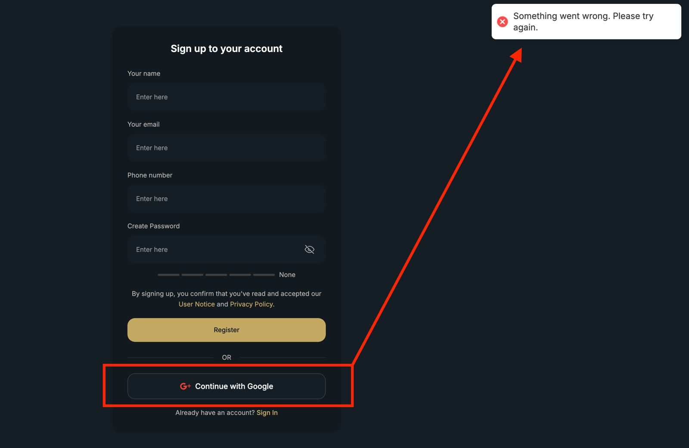
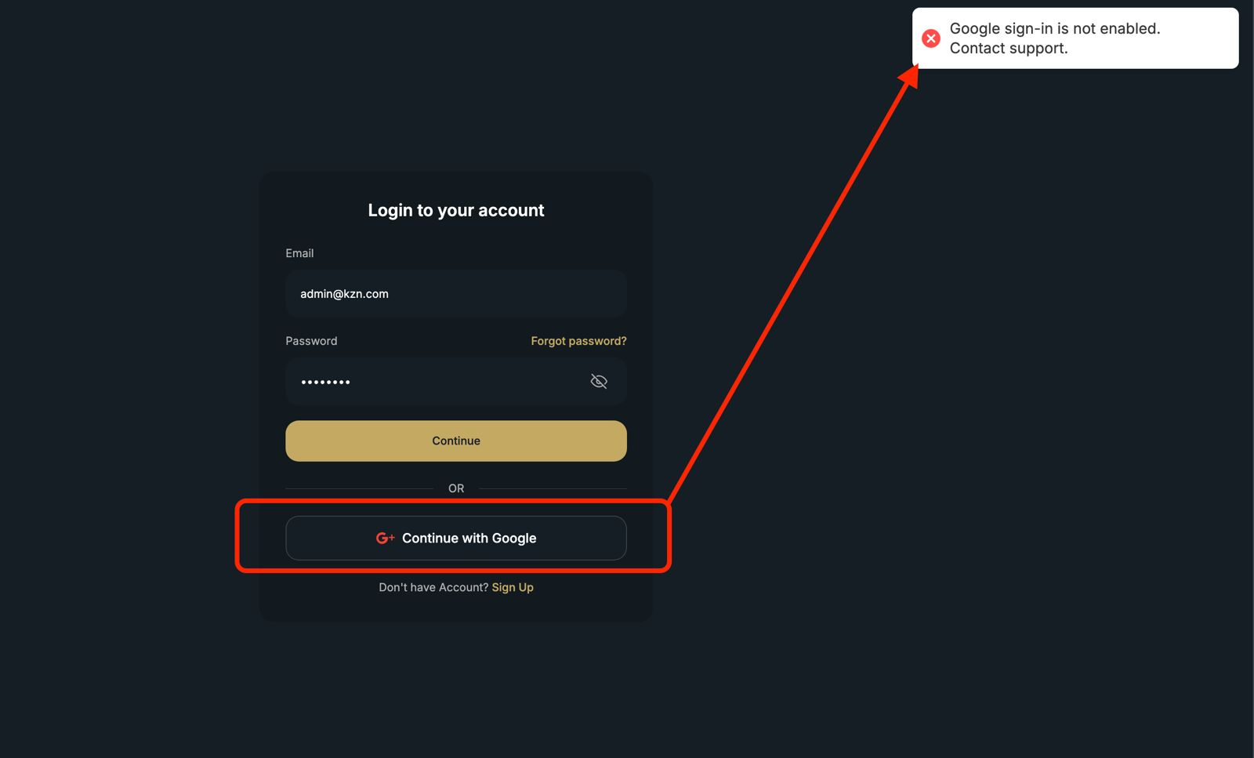
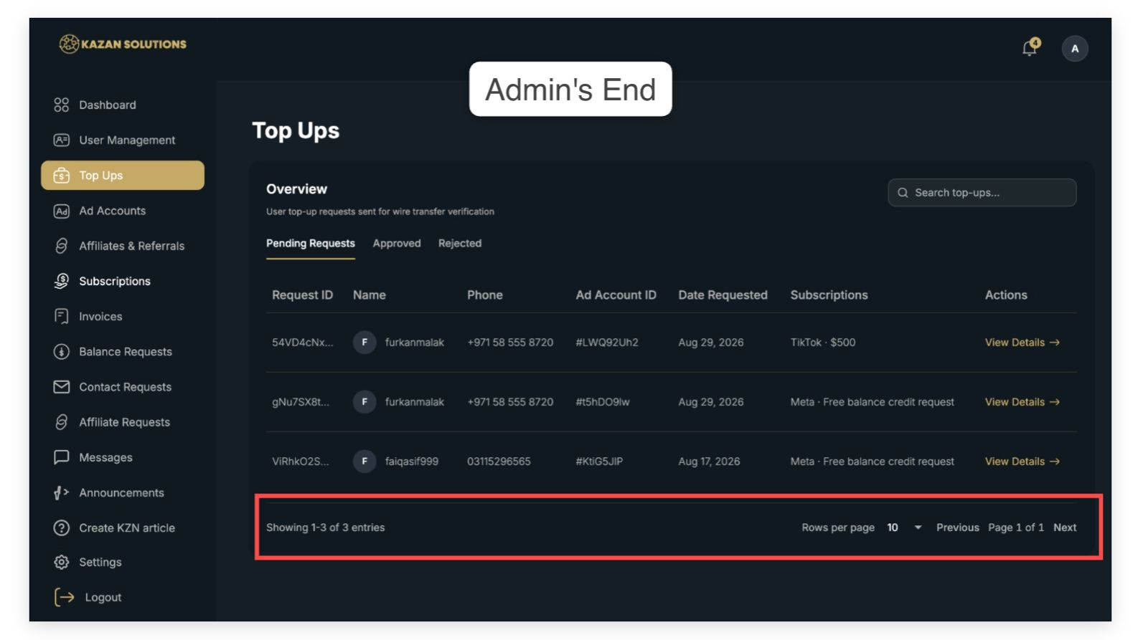
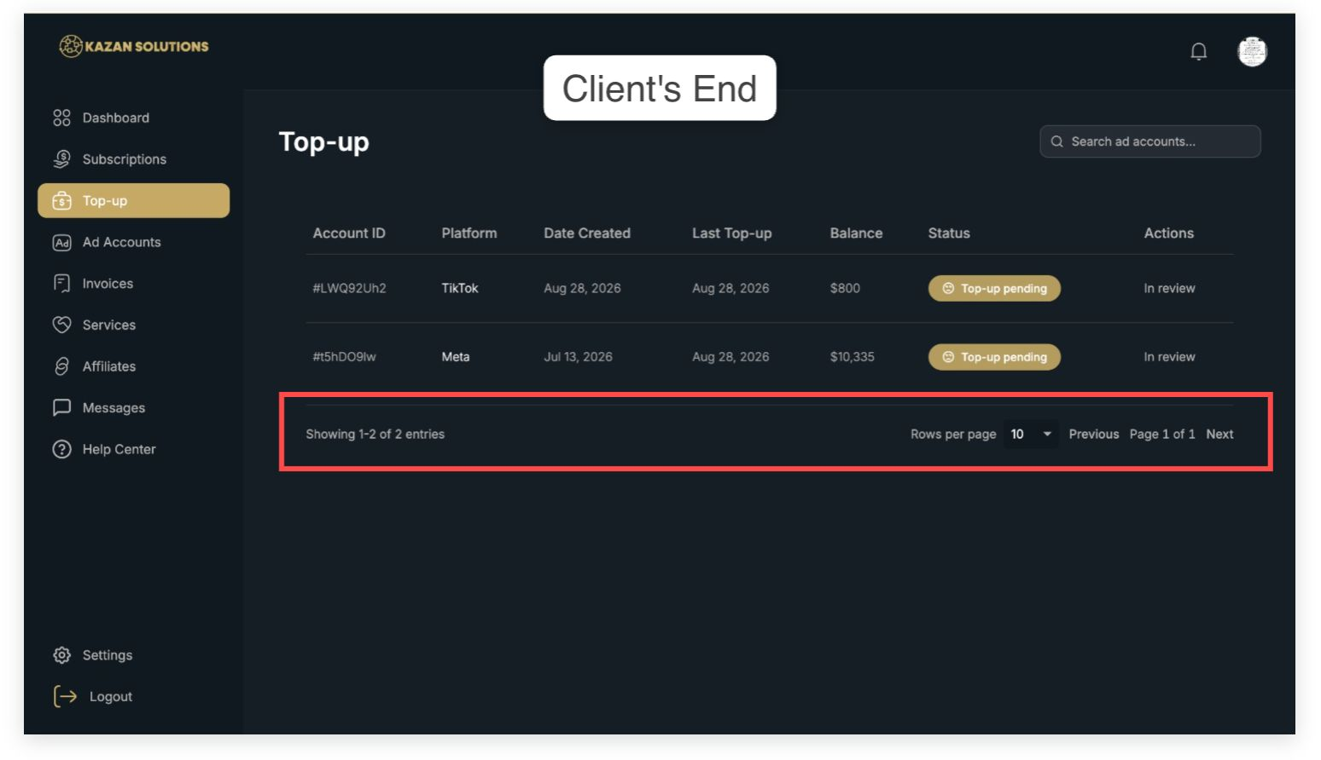
In the mobile version of the dashboard, both "get in touch" and "contact now" details are not properly aligned in the middle, i think it would be better if this would get fixed for the clients who uses mobile phone in accessing the dashboard. Also, when I click the contact details, all of the links are inaccessible.

Discord: Link is expired. -> I'll provide for this soon a new one.

Whatsapp: Sometimes, phone number is showing invalid, sometimes it's working. It should be working all the time. You can also use here the tag @kazansolutions since we got that tag.

Telegram: It's showing Kazan Solutions support chat, but when I click message, it's showing that the address is invalid. Kindly check again @kazansolutions on TG.

Website: Submitted a contact request, but it won't send (something went wrong). Sometimes, I click on it and nothing happened, it goes back to the dashboard and not let me write a request.
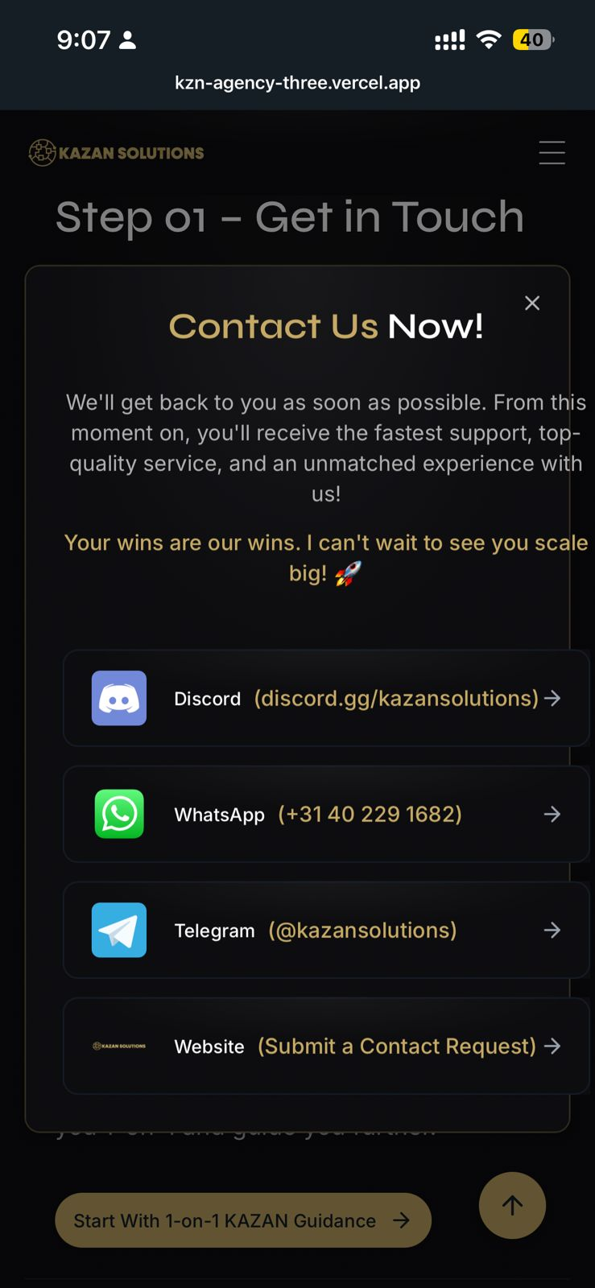
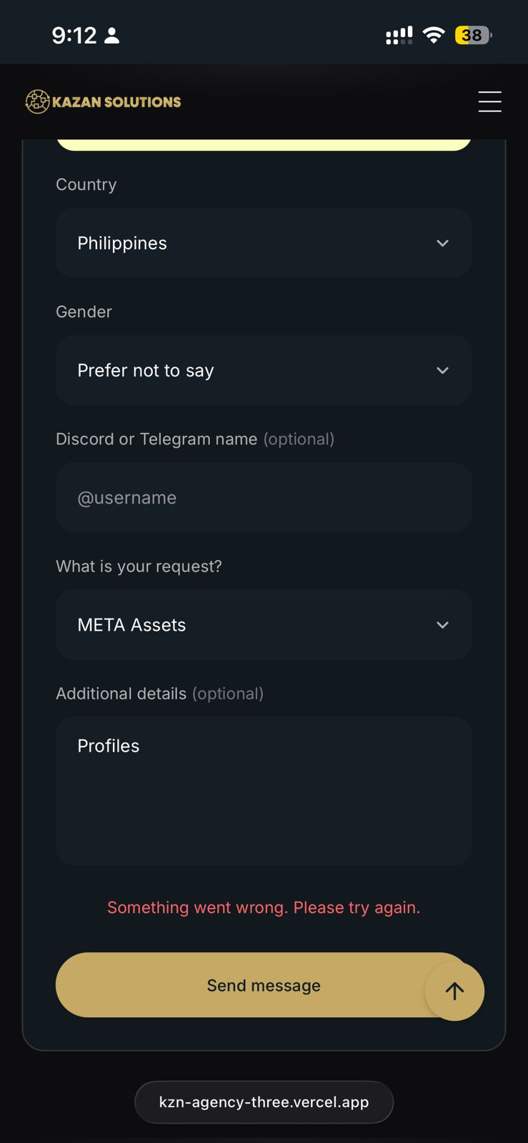
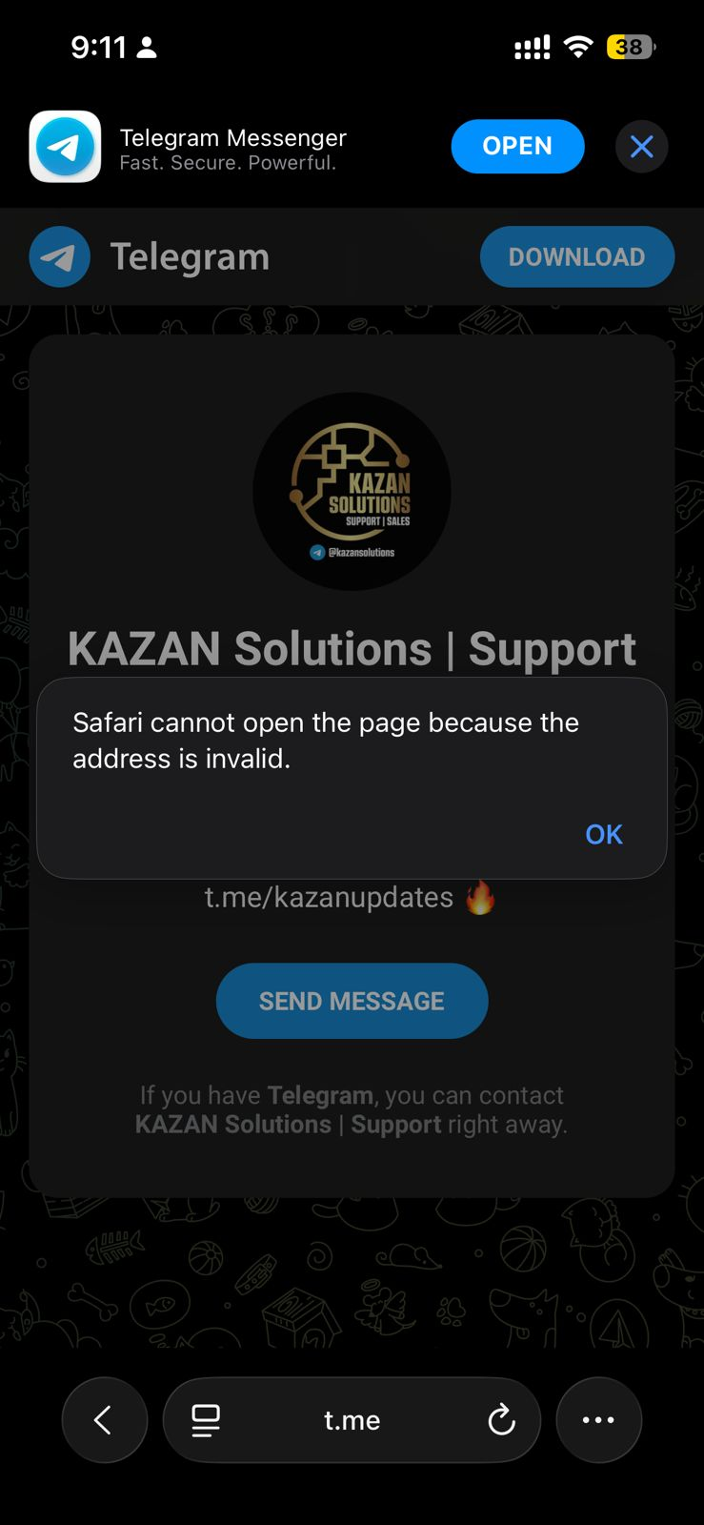
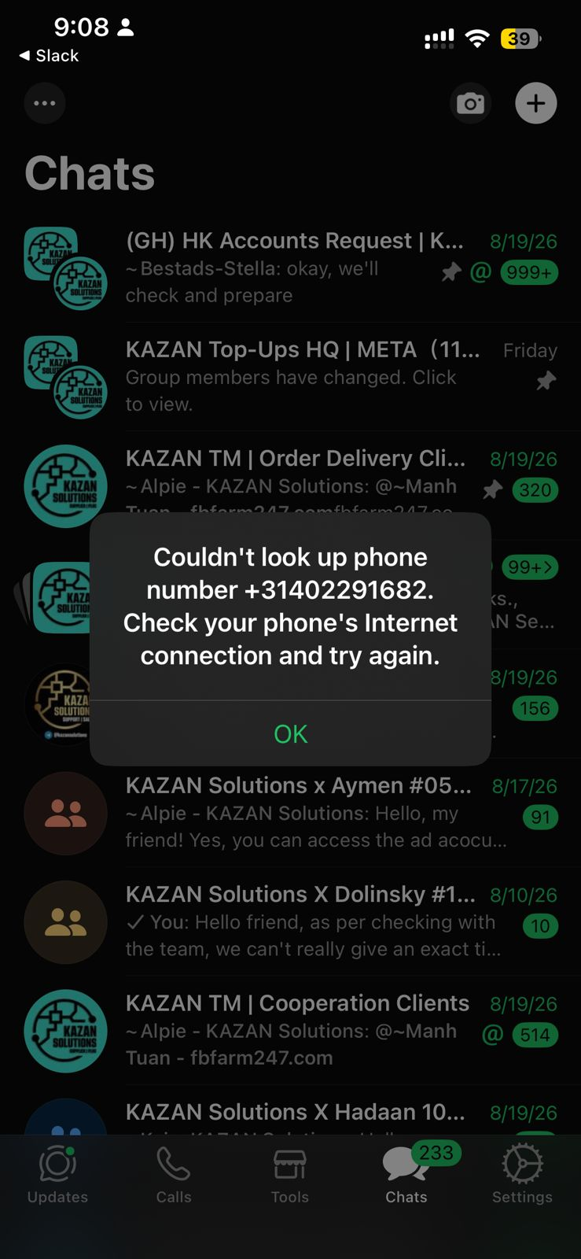
Now it's mixing a lot.
Kindly start working on everything I sent akhi, so we can finalize it really and there won't be any bugs going on. @Faiq Asif
Pricing would be:
START €199/mnd / 2.8%
SCALE €599/mnd / 2.3%
ELITE €899/mnd / 1.8%
Also it's way more protected for scammers.
I'll sent now the META prices and the thing you should do later on I'll sent of all the other platforms.
Pricing page:
KAZAN SOLUTIONS - AGENCY AD ACCOUNTS SERVICES

✅Monthly Subscription Plans:
Choose the plan that fits where you are today! Whether you're just getting started, already scaling, or managing serious volume, KAZAN is built to grow together with you. It’s our legacy as well.

🔥 KAZAN Start | €199/month with 2.8% top up fee
→ Starting out or still testing? Start here.
Perfect if you're starting out, testing new products, or building consistency. Get access to our high-quality Agency Ad Accounts without committing to a high monthly fee.

🚀 KAZAN Scale | €599/month with 2.2% top up fee
→ Ideal for scaling businesses!
Built for advertisers who are already spending consistently and want better cost efficiency as they grow. You get a lower top up fee while having o…
[12:00 PM, 9/28/2026] Faiq Asif: This is 1 pricing for like everyone
[12:00 PM, 9/28/2026] Faiq Asif: than we have this one
[12:00 PM, 9/28/2026] Faiq Asif: KAZAN SOLUTIONS - SUPPLEMENTS AGENCY AD ACCOUNTS SERVICES

✅Monthly Subscription Plans:
Choose the package that fits your advertising needs. Whether you're entering the supplement market, ready to scale, or already managing [12:00 PM, 9/28/2026] Faiq Asif: serious volume, KAZAN provides specialized Agency Ad-Accounts built for supplement advertisers.

🔥 €399/month + 4% top-up fee | Essential
Starting or expanding your supplement brand? Our Essential package gives you access to our specialized Supplement Agency Ad-Accounts with a manageable monthly commitment. Test your campaigns, find what works, and scale when you're ready!

🚀 €699/month + 2.8% top-up fee | Advanced
Your campaigns are performing. Now it's time to scale!
Advanced is built for supplement advertisers who are ready to increase their spend and want better cost efficiency while growing. You get a lower top-up fee with our team right beside you whenever you need support.

⚡️ €1499/month + 1.8% top up fee | Ultimate
For serious supplement advertisers where performance, stability, and every percentage matters.
Ultimate is our highest-level package, built for high-spending advertisers managing serious volume. Get our lowest top-up fee, maximum priority from our team and the most qualitative agency ad-accounts built to support your growth within your space.

🚀 Why Work With Us?
✅The best ad-accounts for Supplement stores.
✅ Free ad-account replacements.
✅ 1 to 7 minutes top-ups, 24/7 availability.
✅ Unlimited Ad-Acc Request.
✅ Ultra-fast replies 10 minutes response.
✅ Highest ad approval rates, less rejections
✅ 24/7 technical support with expertise.
✅ No Spend Issues, No Credit line Issues.
✅ Unlimited Spend, No Spending Limits.
✅ Best Algorithm For Nutraceutical Advertisers.
✅ No random Ad-Acc restrictions/bans.
✅ Higher ad approvals, fewer rejections
✅ Ad-Acc delivery within 36 hours.
✅ All time-zones are available to use.
✅ Policy compliance checks.
✅ Expert guidance (8+ years experience)
✅ Direct META representative.
✅ Cancel monthly.

With KAZAN, you're not just getting an Ad-Account. You're getting a team who stands 24/7 behind you!

Choose the package that fits you today. When you grow, we grow with you. 🚀
[12:00 PM, 9/28/2026] Faiq Asif: So it should be like that people can see the difference between the agency ad-accounts and that we have two options.

Please integrate this.
[12:00 PM, 9/28/2026] Faiq Asif: Also let the dashboard have this packages and that it automatically calculate the % fees correctly based on those packages.
[12:00 PM, 9/28/2026] Faiq Asif: LEGENDARY PACKAGE

High-volume advertisers can apply for a private KAZAN agreement with customized pricing, infrastructure, and support based on their actual monthly volume.

APPLY FOR PRIVATE PRICING -> Make like that people can click on this.

Full Name *
Business Email Address *
Phone Number / WhatsApp *
Company / Brand Name *
Website
What niche are you advertising in? *
Current Monthly Ad Spend * (make here like a dropdown)
$500K-1M
$1M–$2M
$2M–$5M
$5M–$10M
$10M+
Expected Monthly Ad Spend With KAZAN *
Upload Your Last 30–90 Days of Ad Spend *
Upload screenshots or reports showing your recent advertising volume.
[ UPLOAD FILES ]
What are you looking for from KAZAN?
Tell us about your current setup, requirements, or any challenges you want us to solve.

REQUEST MY PRIVATE QUOTATION

Your information remains confidential and is reviewed directly by our team.

Qualified advertisers receive a customized proposal based on their volume and requirements.

Higher volume. Better terms. Infrastructure built around you.
[12:00 PM, 9/28/2026] Faiq Asif: ⚠️ Important Notes:
Please do not include words like “fb”, “ad”, “top-up”, “order”, or your name in the payment reference, this may cause issues with the bank and we can't process your top-up.

You can simply write your Dashboard Account ID.
[12:00 PM, 9/28/2026] Faiq Asif: Put the same text on the USD details brothers.
[12:00 PM, 9/28/2026] Faiq Asif: --------------------------------
This is a general request let the customers always decide with which currency they want to pay the monthly fee with.
If they decide EUR: display the WISE account.
If they decide USD: display the SLASH account.
--------------------------------
Make a little conversion tracker with as calculation that €1 equivalent is to $1.22 so that the monthly fees of for example: €499 changes to $609 when they want to pay with USD.
[12:00 PM, 9/28/2026] Faiq Asif: Also when they request ad-account let them decide which region they want it.

Hong Kong 🇭🇰 & Europe 🇪🇺

Mention there that HK = USD only.
Mention there that EUR = EUR only.
[12:00 PM, 9/28/2026] Faiq Asif: Google Sign-in not enabled." or "Something went wrong. Please try again."

There's an option to Register via "Google account". As a customer, what if I would like my account to be linked with Google. I get this error.
[12:00 PM, 9/28/2026] Faiq Asif: In general kindly check on the Phone how things also look, a lot of thing seems bugging on site and on the dashboard.
[12:00 PM, 9/28/2026] Faiq Asif: We need to have more logins for Admins.

One for the managers and one for the customer service team.

The managers can see everything.

The customer service can’t see the following things:
Settings - Affiliate Requests - Contact Requests - Financial Profits
[12:00 PM, 9/28/2026] Faiq Asif: We need to create a new section called on admin side:

Called: Financial this will be a place where we can track our revenue and our profits everyday so it will count on how much we are when it comes to subcriptions and top-up fees etc. You can work already on a tracking of it so we can see how that looks. Where we also can see how much money has been sent out to WISE or Slash etc. This way we keep our financial strength.
[12:00 PM, 9/28/2026] Faiq Asif: This way, it would be easier for us to receive the payment because they need first to settle everything before they can request a top up.
------------------
7. Expected Benefit
Explain why you believe this innovation would improve Kazan Solutions.
→ Because it's not only about how we organize things like payments, subscription, etc but customers will be able to be obedient and follow rules that we set. This will improve us as well because they will think that we really value the business ethics and rules and regulations.
------------------
8. How Should It Work?
For users, they cannot submit a top up unless the previous payment which should be received by our bank at that specific time is received.
For admins, we can easily check with them if it has been settled or not.
[12:00 PM, 9/28/2026] Faiq Asif: 6. Your Innovation
Explain your idea clearly. What new feature, tool, automation, or functionality would you like us to introduce?
→ In my opinion, it would be nice if we can make those metrics clickable and interactive o, so that when we click on, example, “Total Top ups”, we will be redirected to the Top‑ups section with the relevant details already showing.
------------------
7. Expected Benefit
Explain why you believe this innovation would improve Kazan Solutions.
→ This turns the dashboard section into a control panel rather than just a summary. It can save us time and effort since it reduces the extra navigation steps whenever we just want to check something directly from the dashboard section.
------------------
8. How Should It Work?
Please explain how you imagine the feature working from beginning to end.
If possible, describe the steps:
→ The admin logs in and sees the dashboard section with totals for top‑ups, subscriptions, users, and ad accounts.
→ The admin selects one of the totals, for example 'Total Top‑ups'.
→ The dashboard automatically redirects to the corresponding section, showing the total top-ups made
→ Admins can immediately see the breakdown behind the total amount without extra navigation.
1. Area
Where would you like this innovation to be implemented?
→ Dashboard > Top-up
------------------
1. User Type
Who would benefit from this innovation?
→ Both
------------------
1. Impact
How much value do you believe this innovation could bring?
→ Useful improvement that would make things easier or better
------------------
1. Current Situation
Explain how things currently work and what you believe is currently missing.
→ In the Top-ups section, it only shows pending, approved, and rejected top-ups in a table format. Admins and clients can scroll through entries or use the next page button, but there’s no way to filter by specific dates. This means if someone wants to check top-ups made within a certain period, they have to manually scan through the list, which is time-consuming and inefficient.
------------------
1. Your Innovation
Explain your idea clearly. What new feature, tool, automation, or functionality would you like us to introduce?
→ My suggestion is to add a date range filter to the Top-ups section. This feature would allow us and the clients to select a specific date or a range of date, and instantly view only the top-up requests that fall within that date/s.
------------------
1. Expected Benefit
Explain why you believe this innovation would improve Kazan Solutions.
→ This would make the system more efficient and user-friendly since we can quickly verify transactions, while clients could easily track their own top-ups for their own reasons. It reduces manual searching and saves time for us when checking.
------------------
1. How Should It Work?
Please explain how you imagine the feature working from beginning to end.
If possible, describe the steps:
→ The admin or client opens the Top-ups section.
→ At the top or bottom of the page, they see a date range filter (two fields: “From” and “To”).
→ They input the desired dates or choose from options like “Last 7 days,” or “This Month”
→ The system automatically filters the table to show only the top-ups within that range.
→ You can select the days
[12:00 PM, 9/28/2026] Faiq Asif: We see here on our end how much people are happy/normal/having bad experience about certain services so we can work on that too.
[12:00 PM, 9/28/2026] Faiq Asif: When they click on smiley -> let them also contact automatically support with an automatic message ''I am happy about the service and the quality’' with average not message and with poor ‘’Hi, I am not happy with the service and quality’' so our team can check what is going wrong and work on it.

We can collect this way also more trustpilot reviews if they're happy.
[12:00 PM, 9/28/2026] Faiq Asif: Like what will give people more reason to join us.
[12:00 PM, 9/28/2026] Faiq Asif: Tthe balance request the name of that should change to balance refresh so people will feel it's a real-time tracker when they click on the icon photo I sent that they get a pop-up of in 5 minutes your balance will show-up.
[12:00 PM, 9/28/2026] Faiq Asif: In the upcoming 3 weeks before 21th Sept everything should be done.

I'll sent you within this 3 weeks more details about our other packages and platforms we have so we can finalise that too.
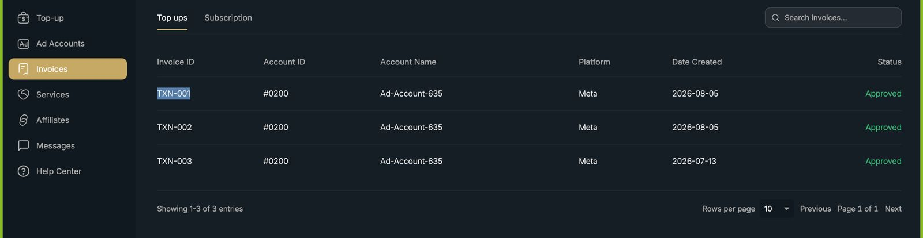
Only little things, such as make an download option so they can download directly their invoice.
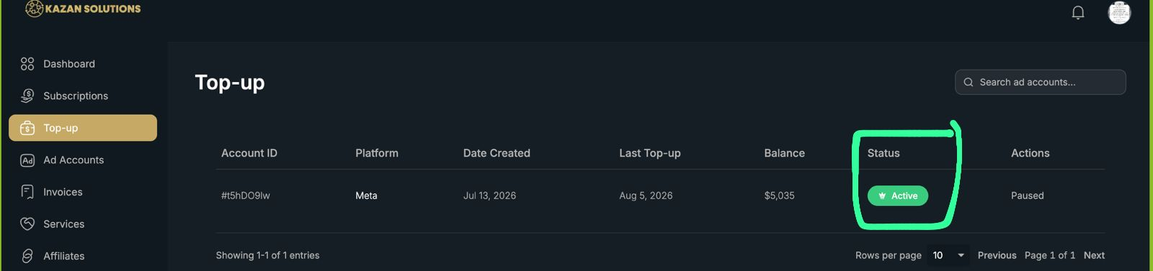
This should be also paused with Yellow colour.
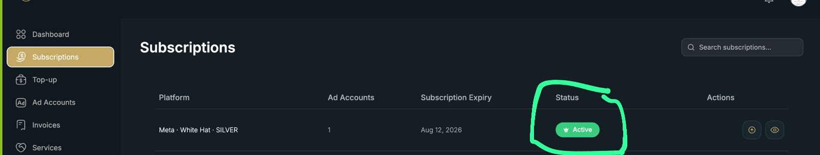
same here

Can you remove the TikTok and put there Telegram Icon with as link to @Kazansolutions on Telegram and same for IG.

People can't click on their name to go to the settings pls put there a redirection.
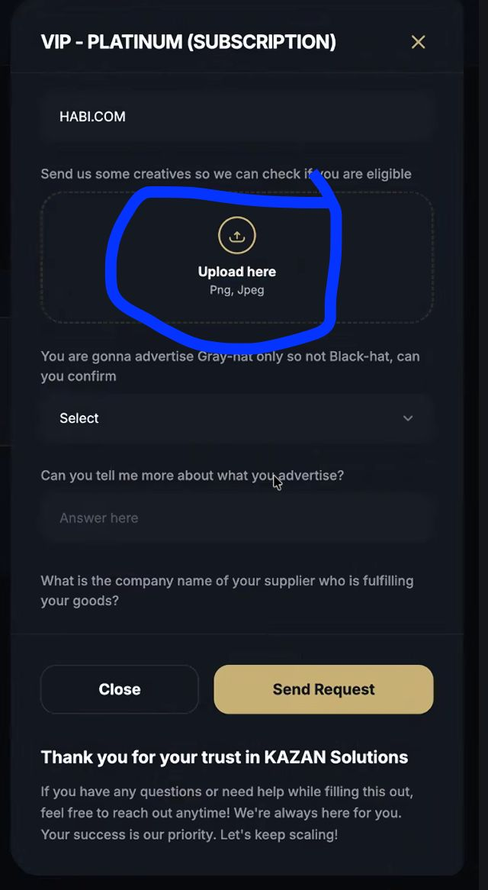
Also there is a bug, customers can't upload when they do a request subcription or ad-account.
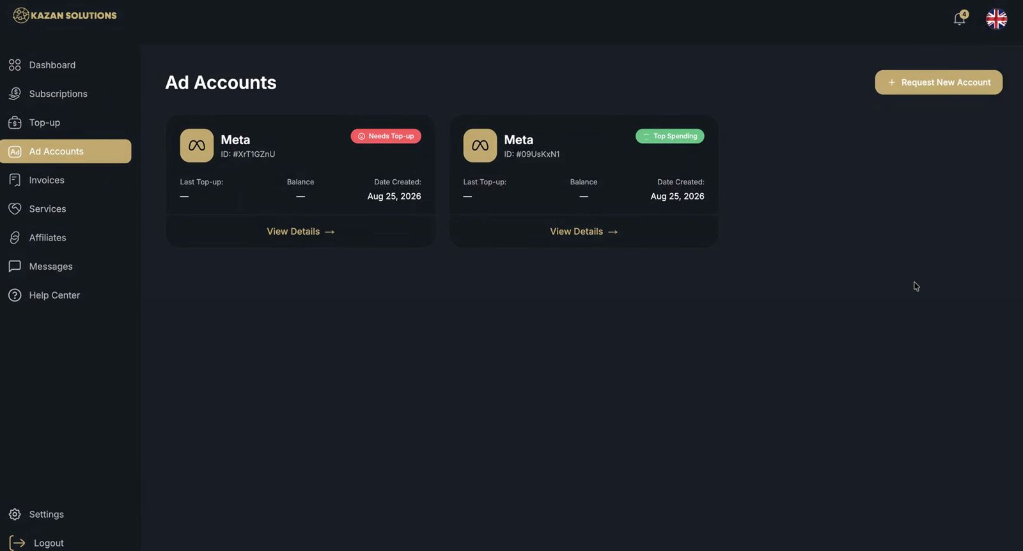
One is VIP subscription ad-account one is with Silver, it should be clear which one is which one.
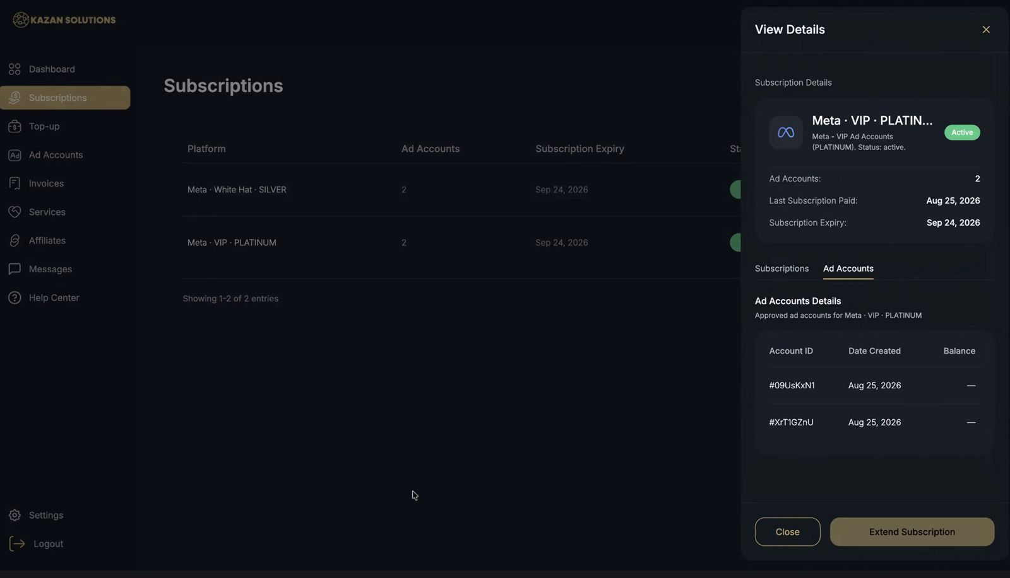
We have 1 ad-acc for WH and for VIP.

But it's mixing. So when you click on the VIP Platinum subscription it says that it has 2 ad-accounts but it actually has one.

Maybe a new section in Ad-accounts with plan names would be useful?
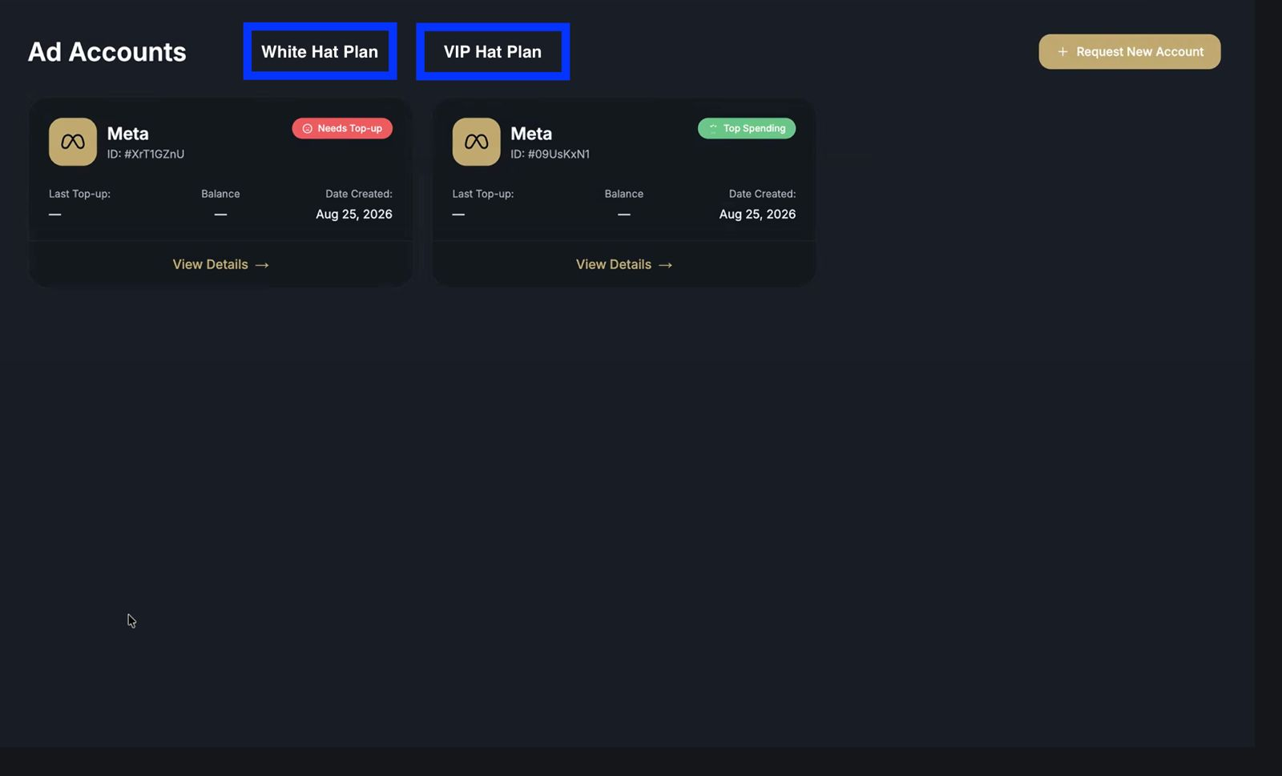
I think this would be way smarter to divide the ad-accounts carefully. So that people can click on their plans and see there the ad-accounts based on the plans and if someone have only one plan that this won't show up.
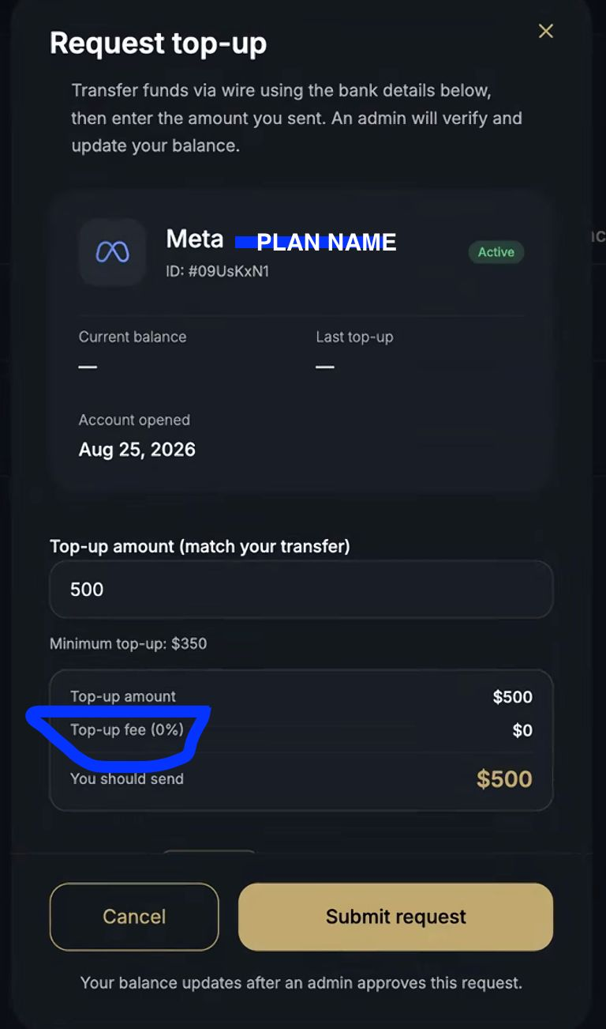
Also the top-up fees are not calculating well my friend took Silver and Gold both and both are on 0% fee meanwhile the pricing is different it's actually 3% and 2% fee.
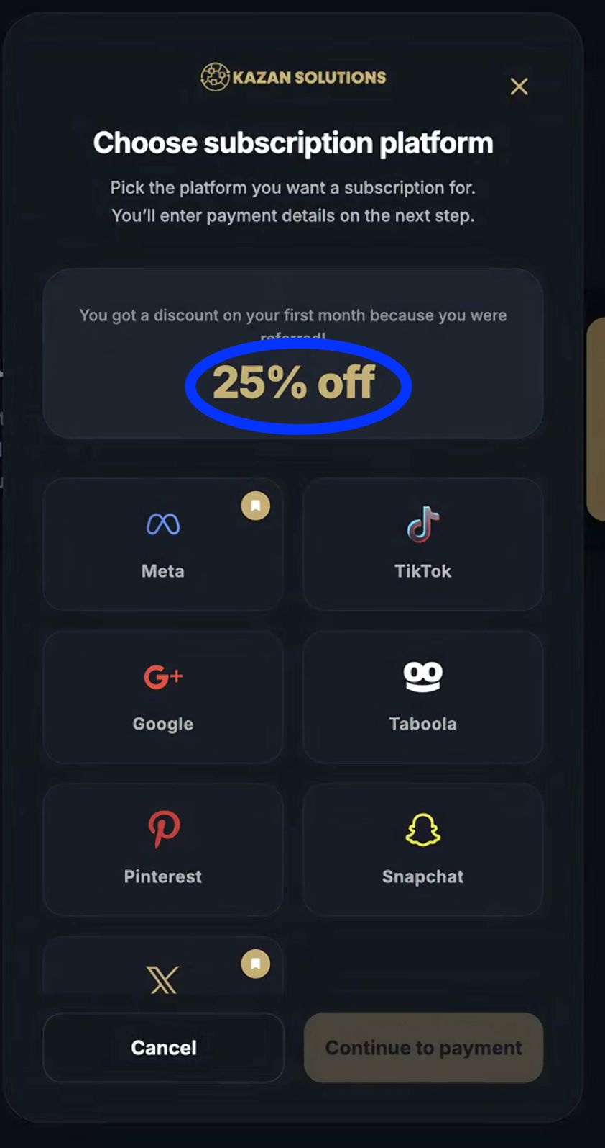
This should be 10% and you guys did fantastic job because the 10% is already calculating on the page where they want to buy the subcription. So only here 10% as change of text.
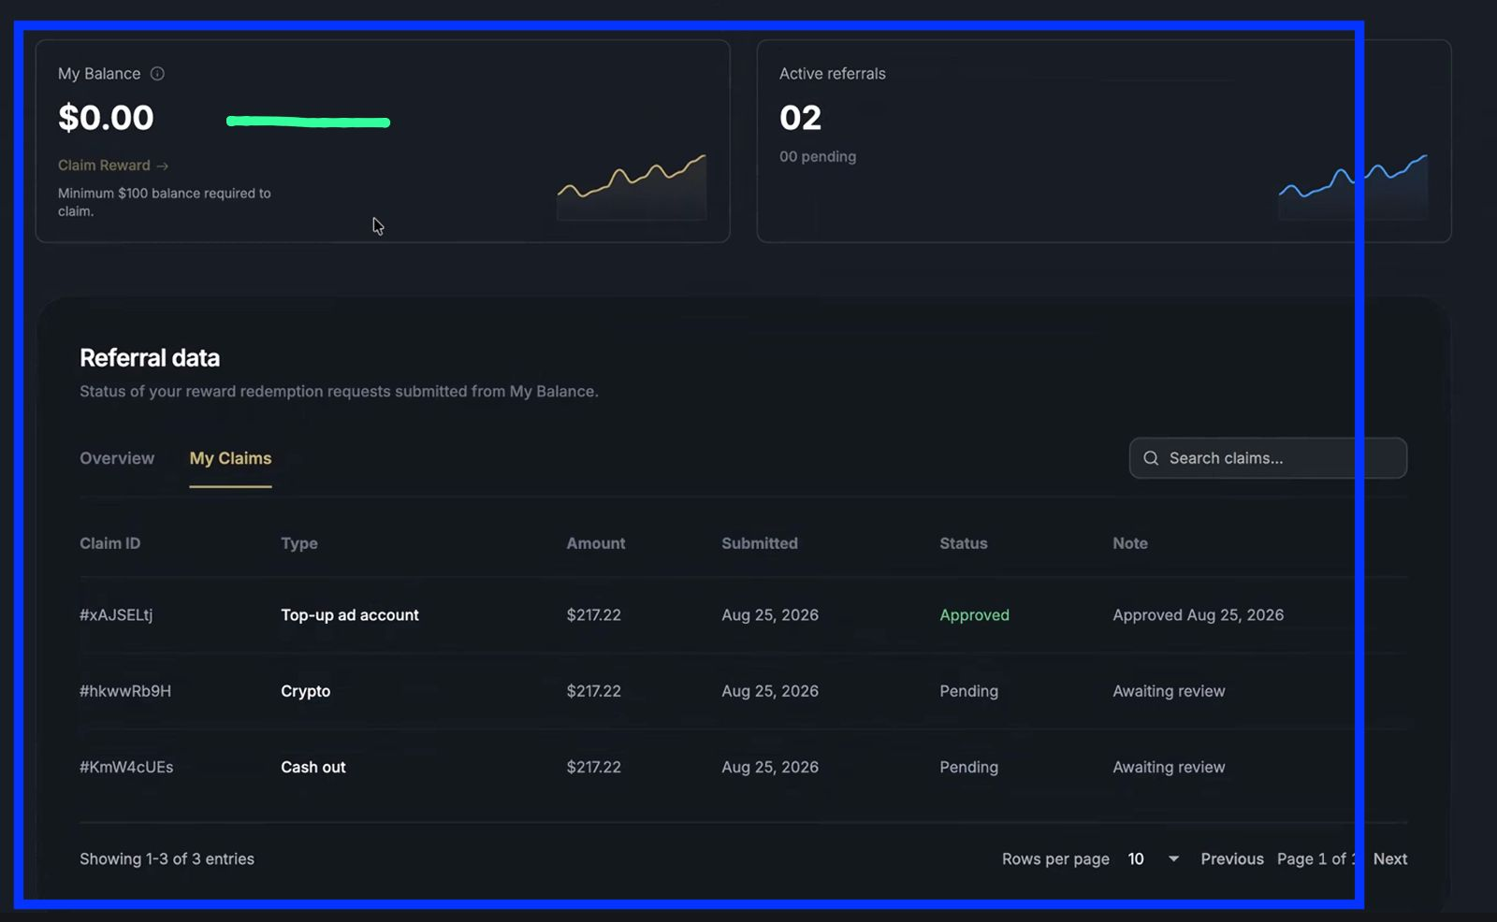
Our referrals can spam here the claim. So after they request the claim put on the green line - Your request is pending.

So they can't click on Claim Reward anymore and make the Minimum $100 balance requred to claim in one alinea.
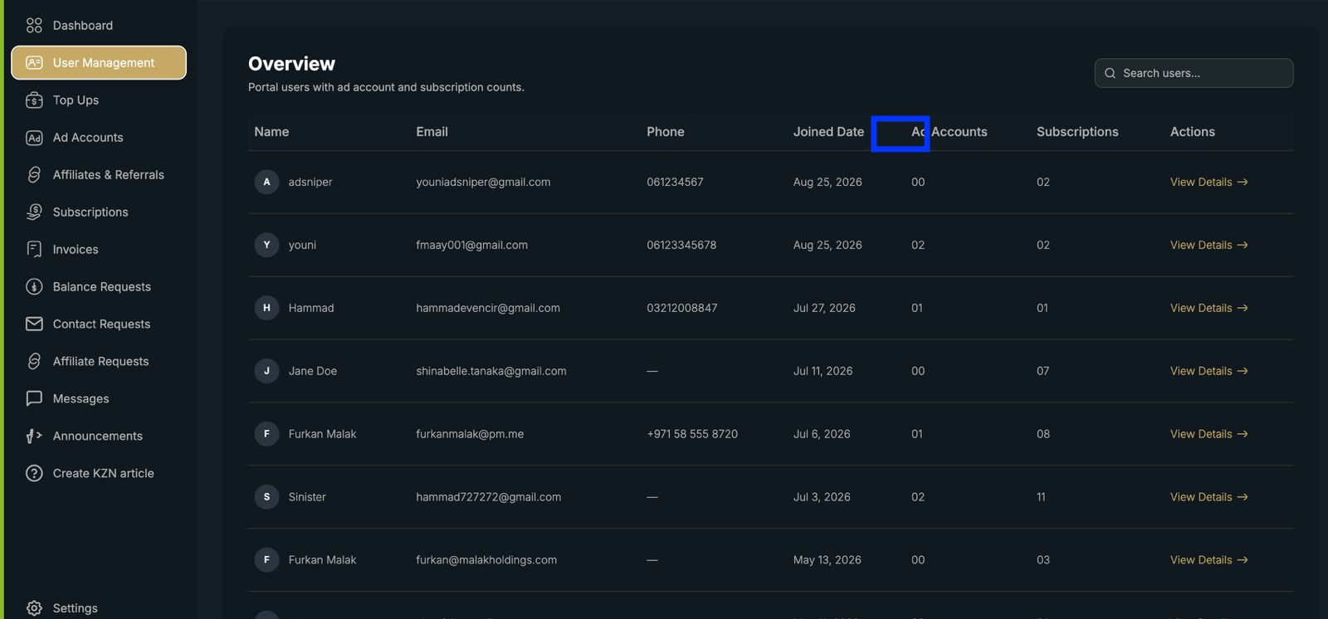Also here put something as Last Login
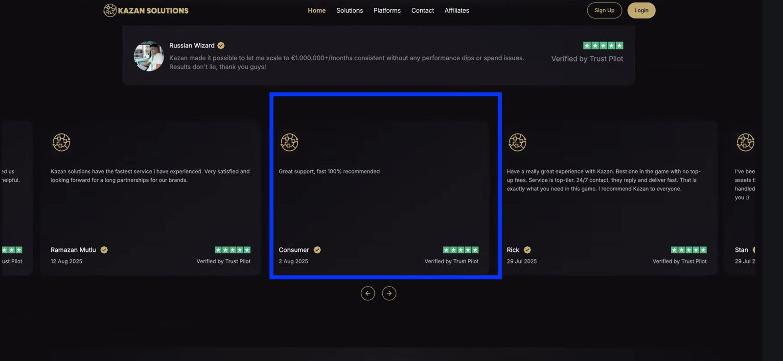
On the site it should be possible to click on the reviews, when they click they will get referred to the Trustpilot reviews. Also put an automation with all of our trustpilot reviews what get added.
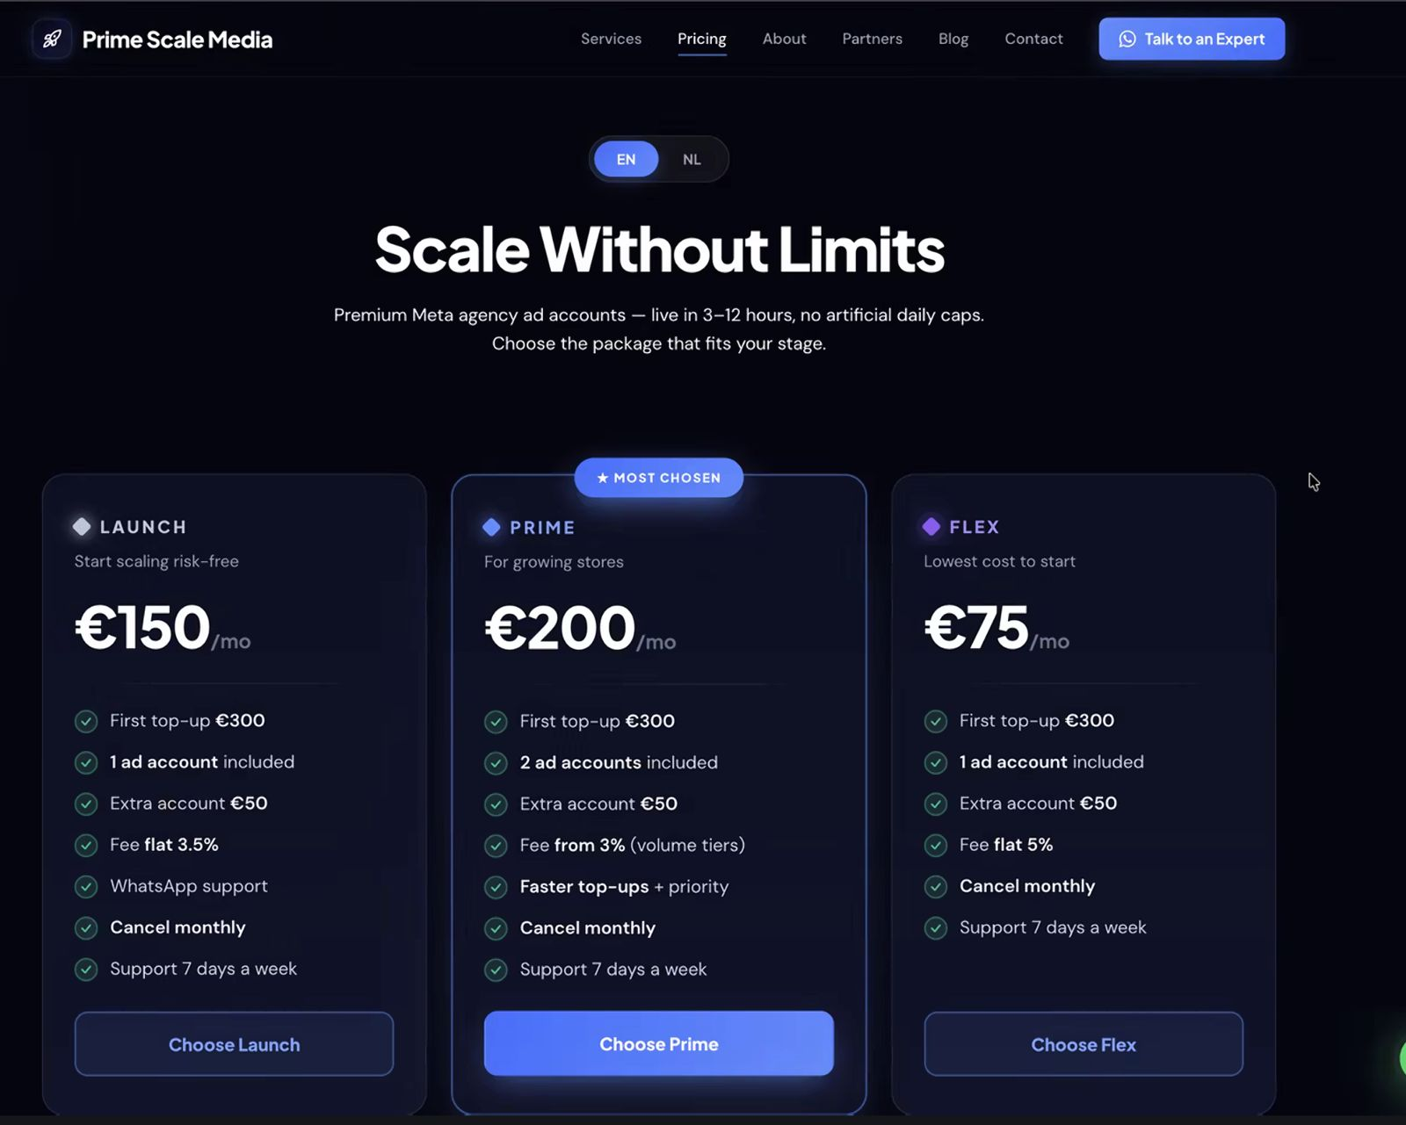
Also for pricing we need to have this.

English only.

I'll sent you today all the new prices for every platform etc.

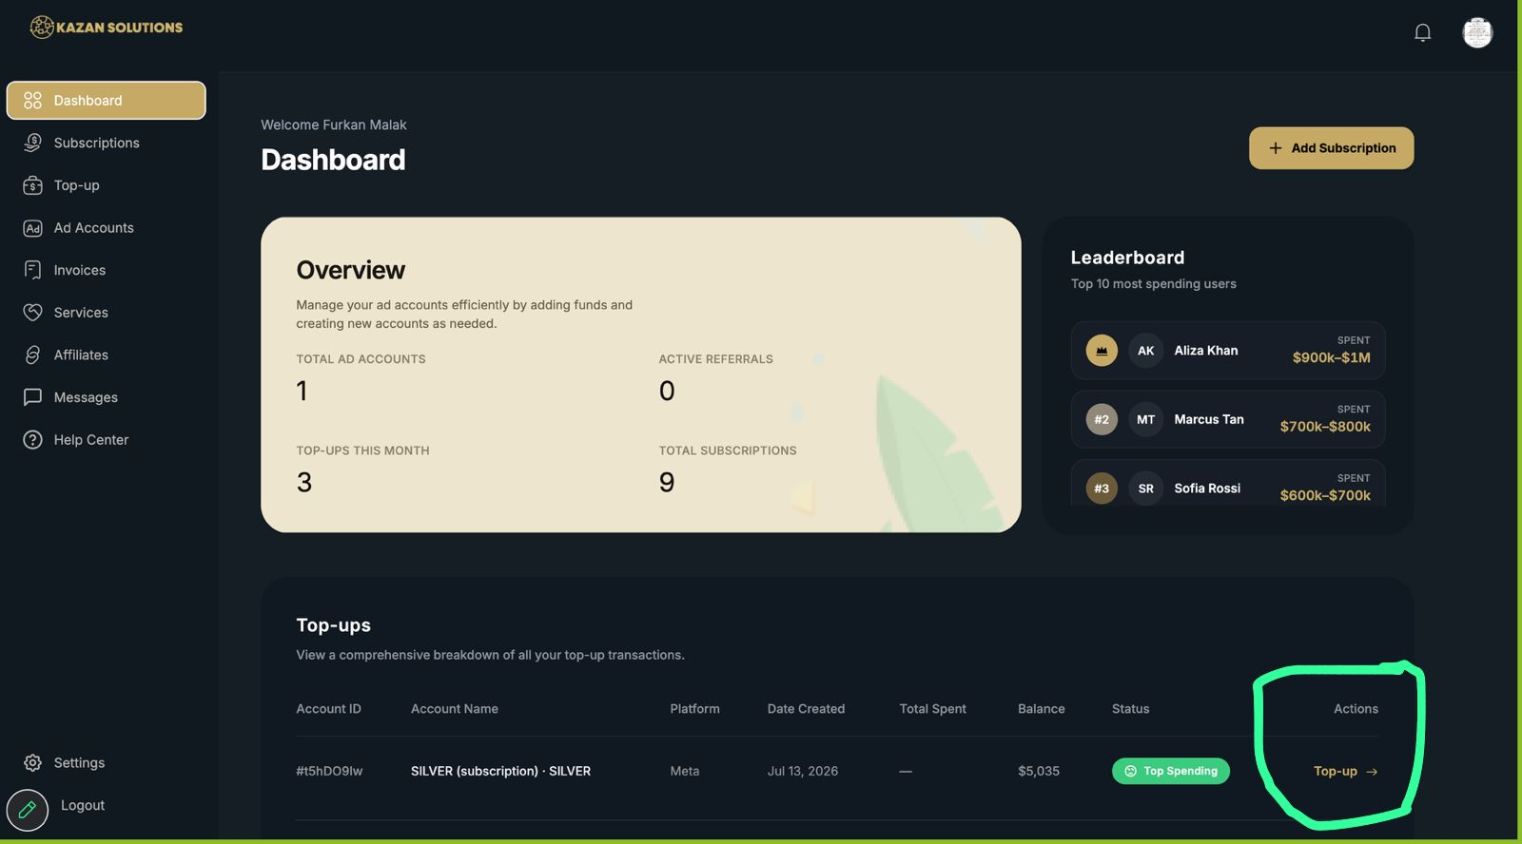There are bugs with top-ups.

When the subscription isn't paid. The customers, can go to the dashboard and click on top-up and if they click it will still work to do a top-up.
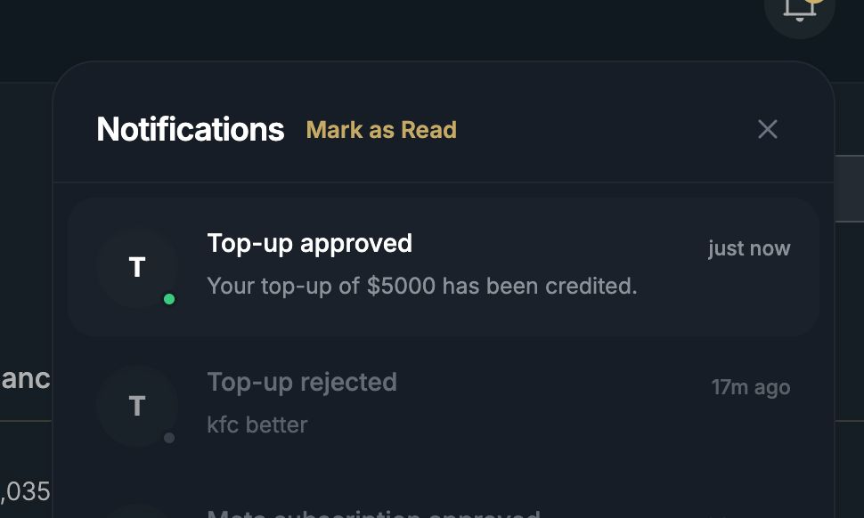Also make a notification pop-up when top-up is approved or rejected so customers can be aware of it instead of checking this one. Also let customers click on those things to redirect to their ad-account where the top-up is been done so he can see it there.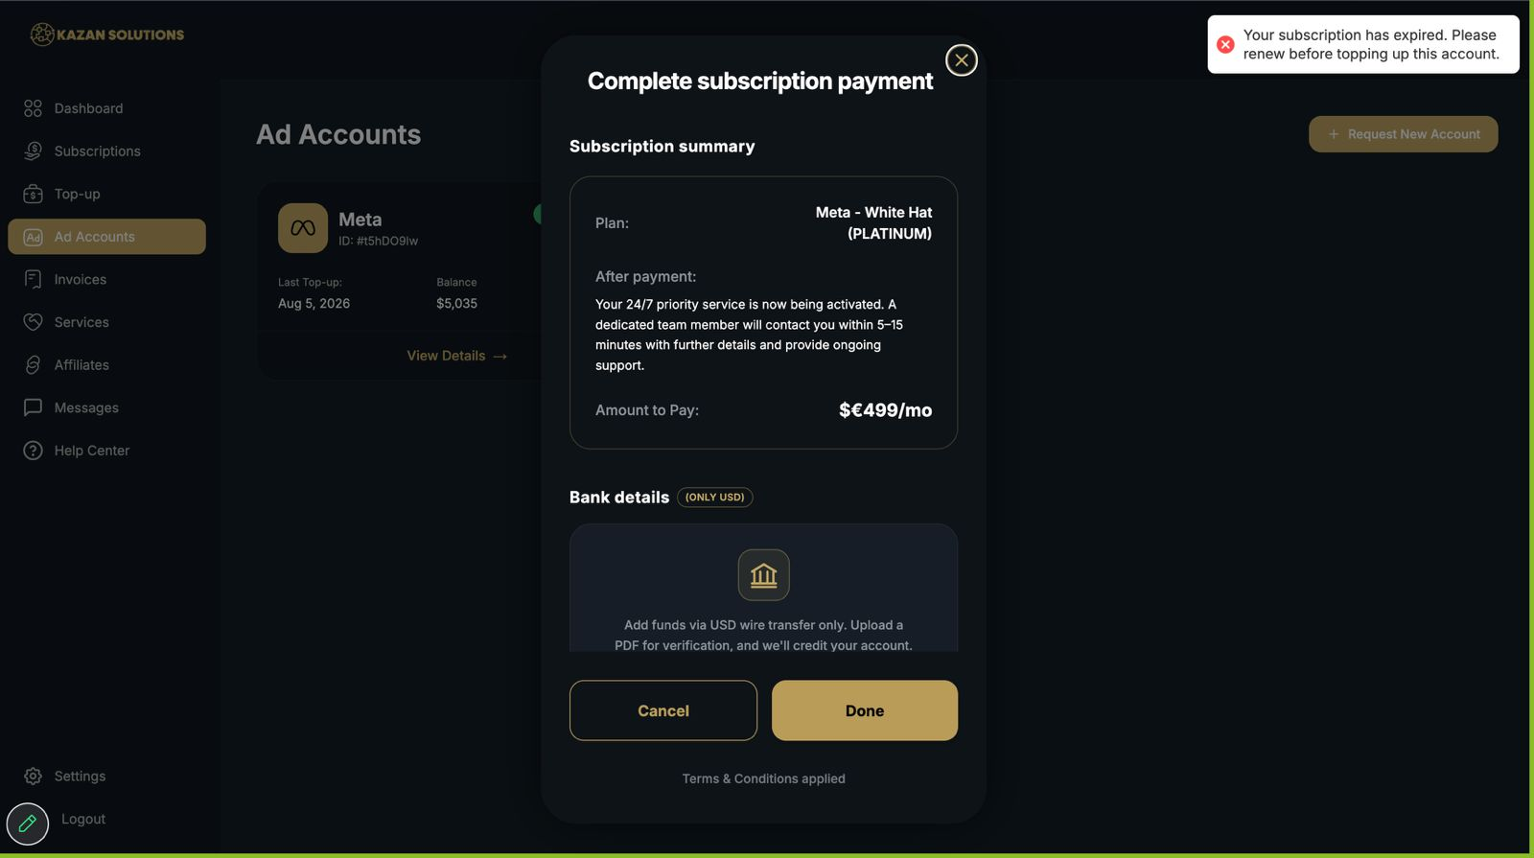After confirming the first top-up, when I want to do the second top-up it says that I need to pay for my subscription even it's very new. Make a day count of 28 days that this pop-up will come every 28 days after their purchase.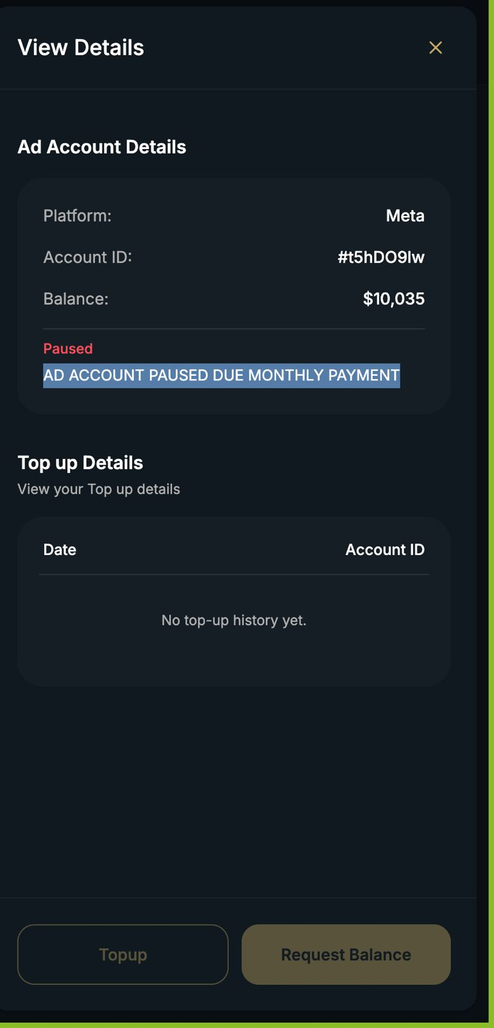
On the ad-account side it's working but only from the dashboard ppl can still do top-up.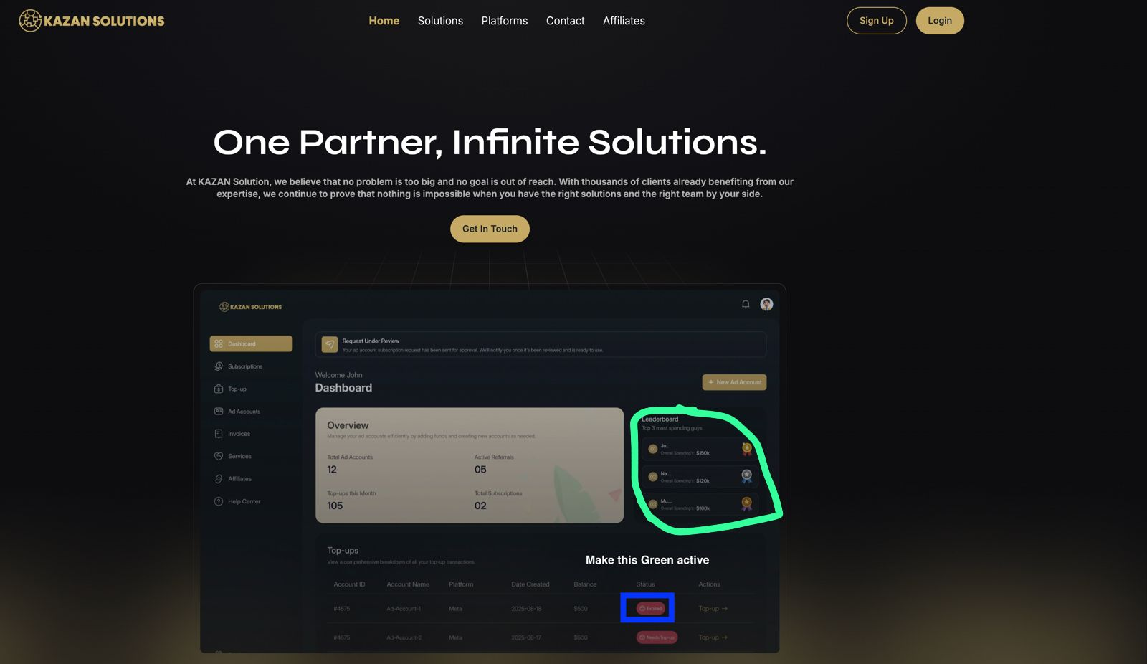Also make Active referrals like 12 and the top-up for this month 205 and here as how it is now and the 1st one has $9.000.000+/spend the 2th one $7.650.000+/spend and the 3th one have 6.980.000+/spend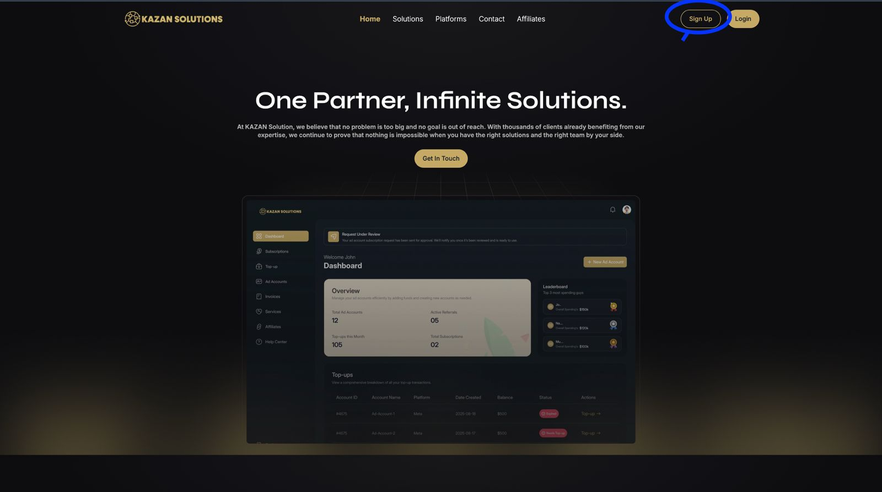When people want to sign up and when they join the dashboard after they only need to see the ''Subscription part’' after we confirm their payment they can start see and use the ad-accounts/top-up and all the other sections. So it feels more exclusive.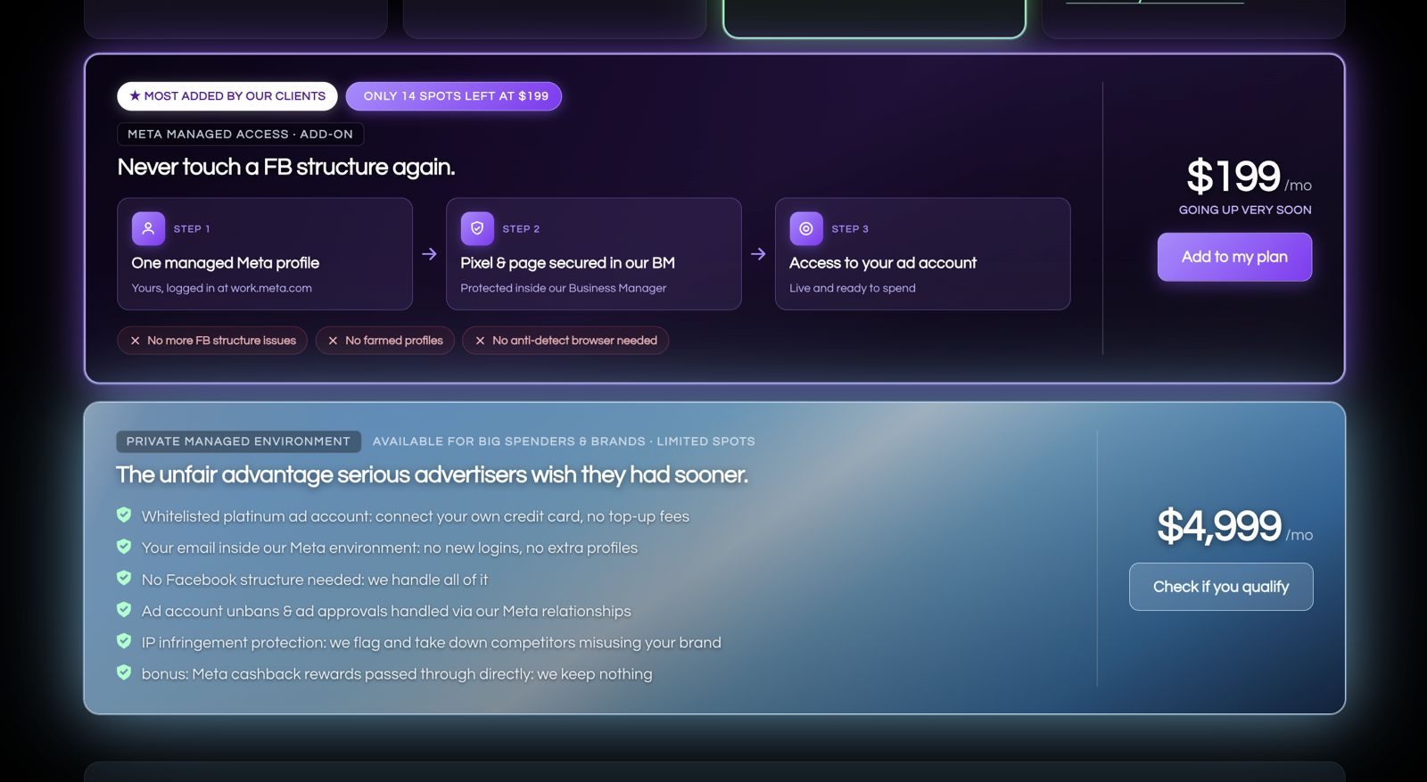https://ad-guardians.com/pricing/

Make it similar to how they did it but then way better.

Also for that one thing they have below with like those stuff, I'll come with it soon.
OPTION 1: Send to our WISE EUR Bank Details:
--------------------------------
Beneficiary Name: KZ Digital Media Group LLC
Account Number/IBAN: BE27 9059 1606 4973
Routing Number: 121145307
SWIFT Code/BIC: TRWIBEB1XXX (Use when sending money from outside SEPA)
Beneficiary Address: 30 N Gould St Ste R Sheridan, WY 82801-6317, US
Bank Name & Address: Wise, Rue du Trône 100, 3rd floor, Brussels, 1050, Belgium
--------------------------------
OPTION 2: EUR Details Send via WISE to WISE. (Preferred way)

For your convenience, you can also send your payment directly from your Wise account to our Wise account.

➡️ WISE Account Name: KZ Digital Media Group LLC
➡️ WISE Tag: @kzdigitalmediagroupllc
➡️ WISE Payment Link: https://wise.com/pay/business/kzdigitalmediagroupllc

You may also use the QR code below provided in the payment instructions.
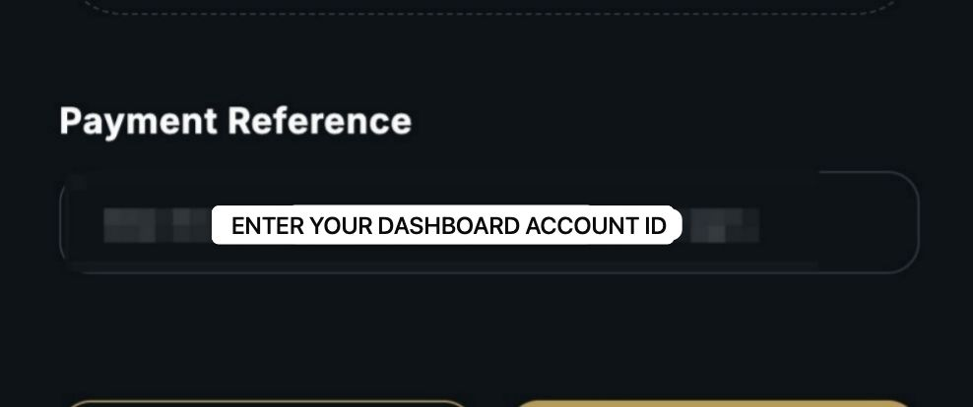Customers sometimes ask what to put in the payment reference. So we can change it to this.
<video attached for reference>
If I click on "Know more about it" I go automatically to help center doesn't make sense atm since we need to make the PDF's later it should redirect to the help center for now let it go to the messages.
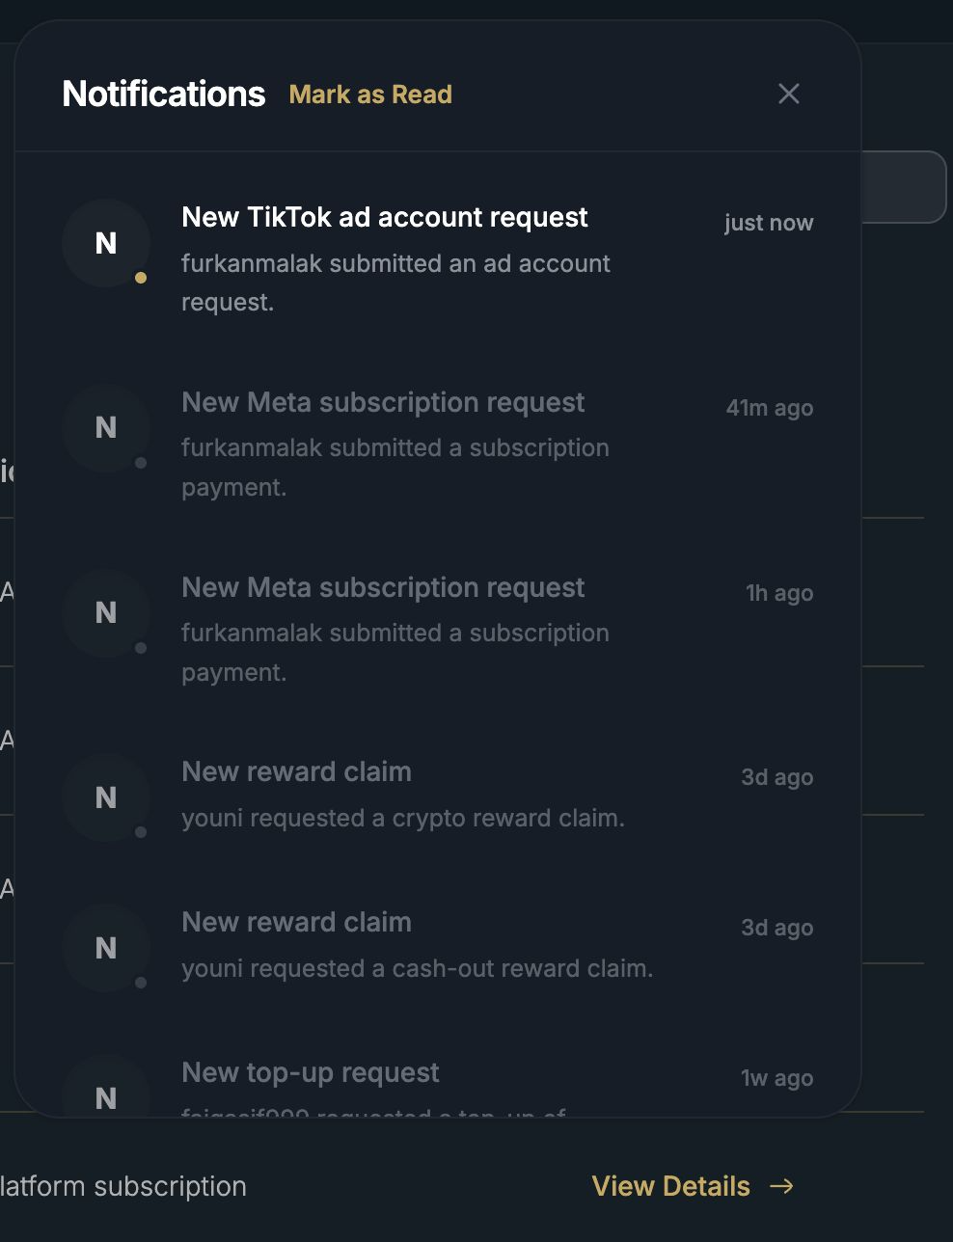
Make sure that you can click to each message what will redirect you to the place itself.
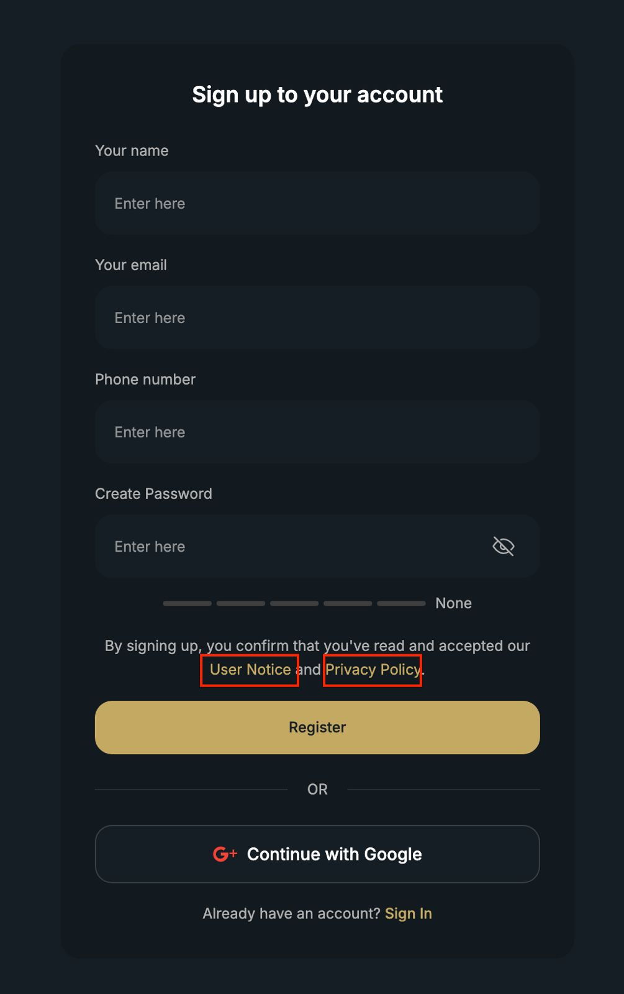
Also on SIGN UP TO YOUR ACCOUNT screen, the hyperlinks "User Notice" and "Privacy Policy" does not open or direct to the page or message something. It remained unchanged on the same page. You can click the both links above also that it will just show you sign up form.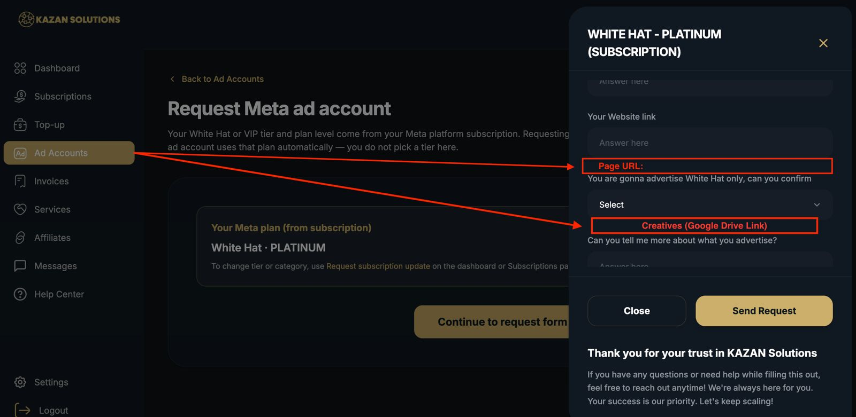
Section for Page URL.

Then for the creatives, I think it would be better if there's a section where they can paste the google drive link of it so we can check it.
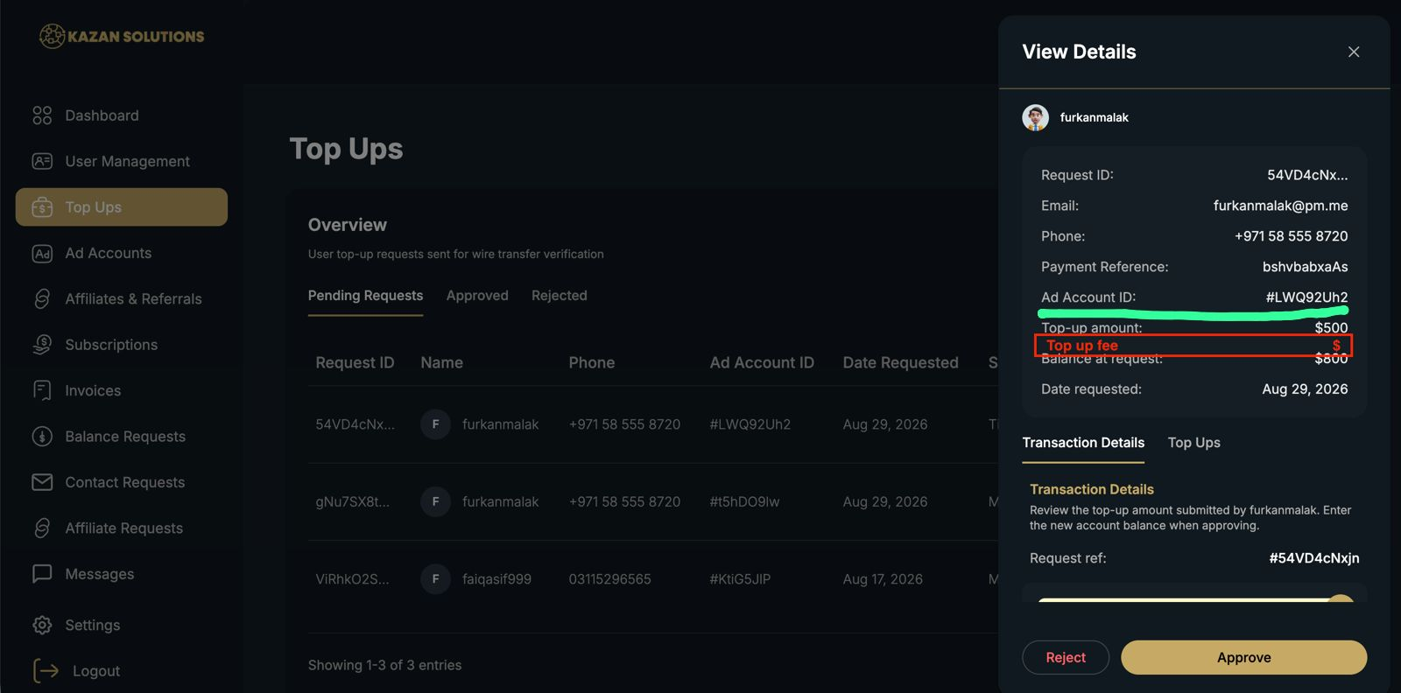
It's better to have a "top up fee" section here on the Red side so admins can also check how much profit we got from that payment.

We can also check if the amount they sent is correct

On the green side that we will see their package name only so we can see if the calculation is correct even it's correct calculated we will always recalculate it since we work with tiny margins on %.
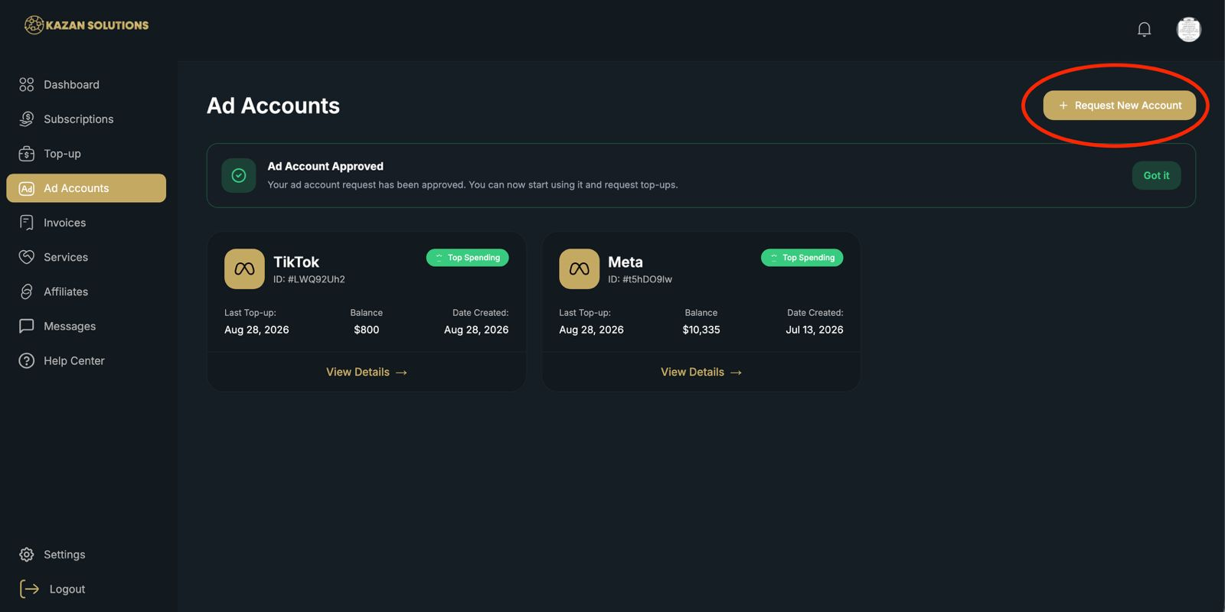
1. Area
Where would you like this innovation to be implemented?
→ Dashboard > Ad account Request section
------------------
2. User Type
Who would benefit from this innovation?
→ User
------------------
3. Innovation Type
What kind of innovation are you suggesting?
→ Automation
------------------
4. Impact
How much value do you believe this innovation could bring?
→ Could save significant time or improve the customer/team experience
------------------
5. Current Situation
Explain how things currently work and what you believe is currently missing.
Like restriction in doing top-ups, we can restrict them at that page to request for a new ad account.
------------------
6. Your Innovation
We can have this button where they're not allowed to request a new ad account if Subscription still not settled too.
------------------
7. Expected Benefit
Explain why you believe this innovation would improve Kazan Solutions.
→ Reduce manual work. Increase automation.
------------------
8. How Should It Work?
Please explain how you imagine the feature working from beginning to end.
If possible, describe the steps:
→ What should the user/admin see?
→ What should they be able to do?
→ What should happen after an action is taken?

If the User is logging in his account at start, he's also having notification pop out, correct?
If he tries to make top-up payment, he cannot do it. So we can apply it to the ad account request also.
(From the admin side), we wouldn't have a long list to check/approve on our end/admin side + they'll be forced to pay the monthly fee.

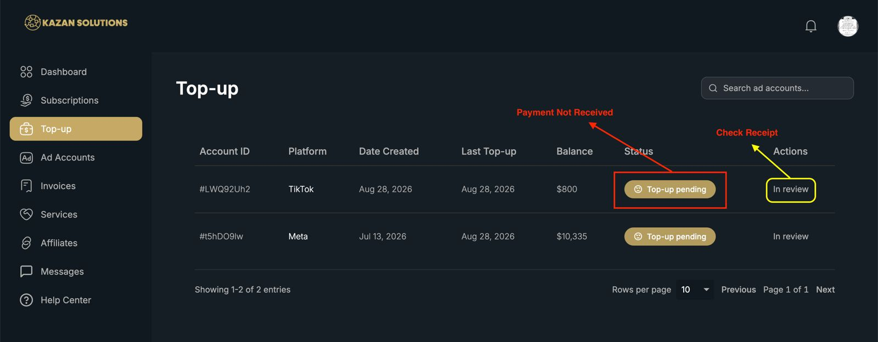1. Area
Where would you like this innovation to be implemented?
→ Dashboard > Top Up
------------------
2. User Type
Who would benefit from this innovation?
→ User
------------------
3. Innovation Type
What kind of innovation are you suggesting?
→ New Feature / Automation / New Tool
------------------
4. Impact
How much value do you believe this innovation could bring?
→ Could save significant time or improve the customer/team experience
------------------
5. Current Situation
I've noticed that some customer's payments needs to be followed up since the payment was not received yet by our bank. It takes some time for them to reply.
------------------
6. Your Innovation
We can message them on WA or here on our dashboard and if we did not get a reply or they did not settle it, they can check it on this section. If we have a new status here (with red box), they would know that the payment was not yet received by our bank from that specific top up. Then on the action section (with yellow mark), they can view the receipt which was not yet received so they can check it on their end.
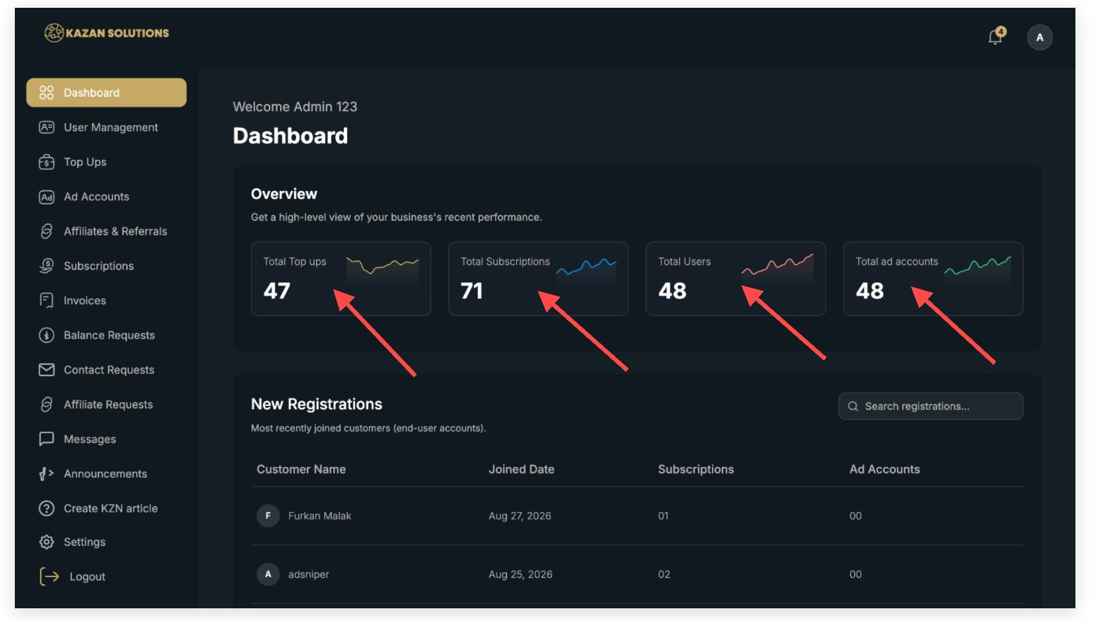1. Area
Where would you like this innovation to be implemented?
→ Website > Dashboard section
------------------
1. User Type
Who would benefit from this innovation?
→ Admin
------------------
1. Innovation Type
What kind of innovation are you suggesting?
→ Automation
------------------
1. Impact
How much value do you believe this innovation could bring?
→ Nice addition that could improve the overall experience
------------------
1. Current Situation
Explain how things currently work and what you believe is currently missing.
→ In the dashboard section, there's already an overview of the total top-up amounts, total subscription, total users, and total ad accounts but we can't click on it. If you want to see the breakdown (like which user topped up, or which accounts are active), you have to manually navigate to the specific section in the sidebar. This makes the overview useful for quick reference but not very interactive.
------------------

Also instead of maybe services we can create like a ''Shop'' where people can see all our products and just click and sent money to it.
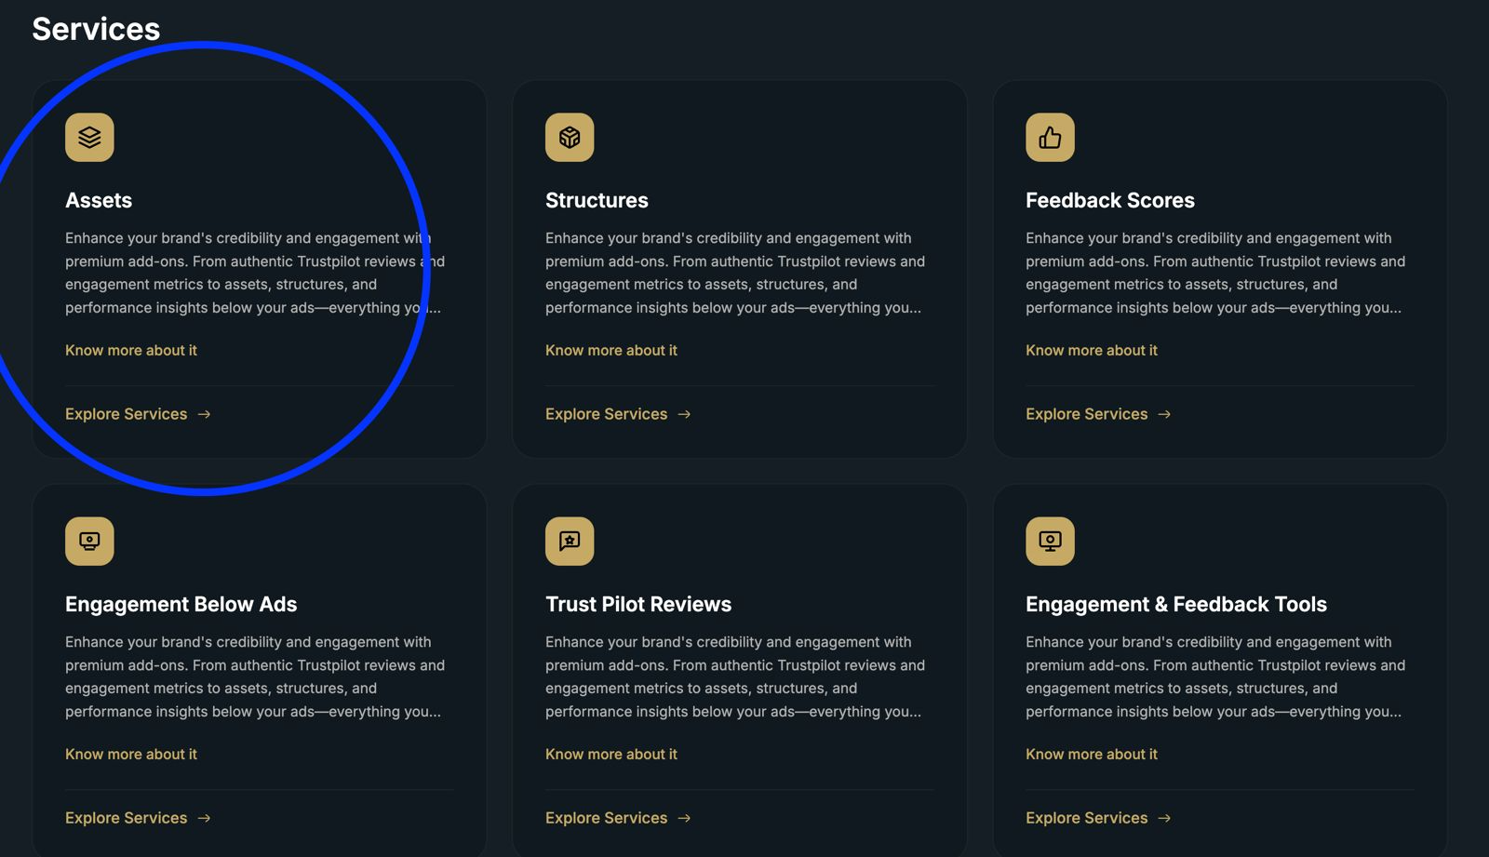
let's say they click on this one.
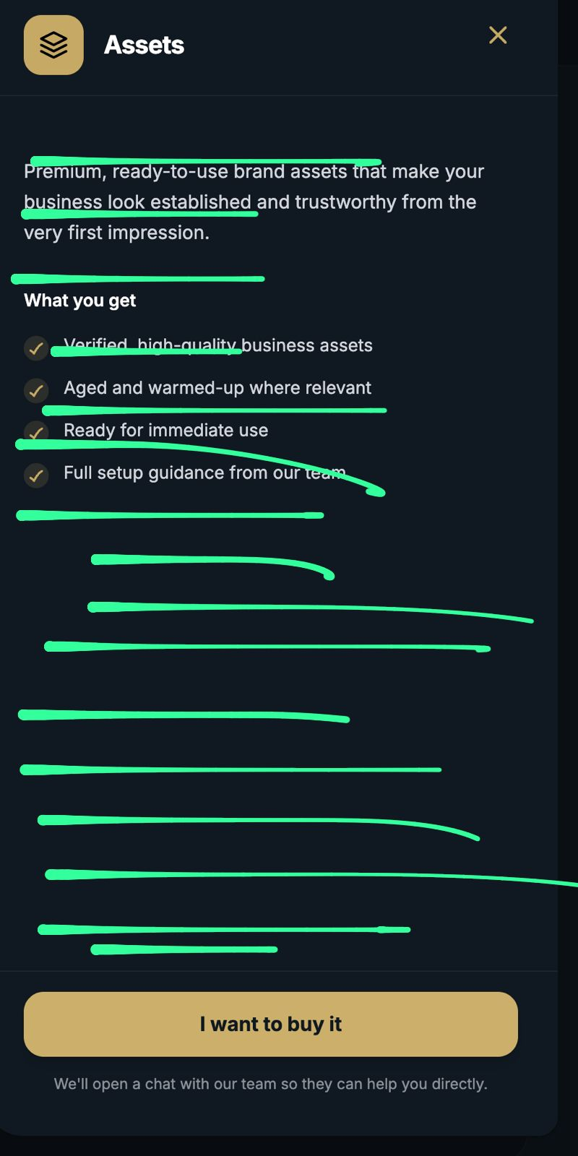
they will see here like a list with all our prices and all our stuff.

When they click on something they will get a pop-up with ‘’Proceed with the order'' after that they will get a pop-up with ''Buy the item’’

When they buy items they can only pay it with USD and not EUR.

So there you can put that paying services besides of agency ad-accounts aren't allowed to being sent to WISE.

So then they can pay the item and upload the screenshot.
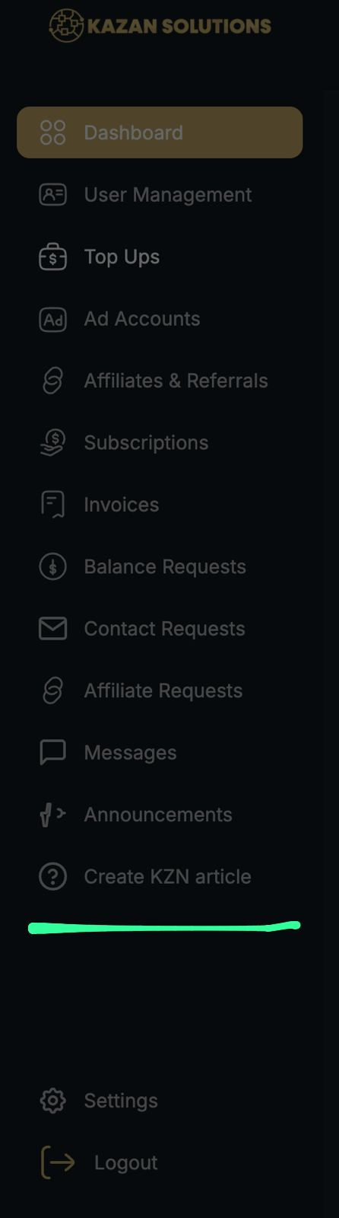
On the admin side we would need to have a section called ‘’Orders'' and we will be able to see ''New orders'' & ‘’Pending orders'' & ''Delivered orders''

A little count bar that we also can see how many pending orders/new orders we have.

Also an average of smileys (see the picture complete below to understand).

Every order will come directly to here.

After we deliver it and put the details there they will get a pop-up on their side.
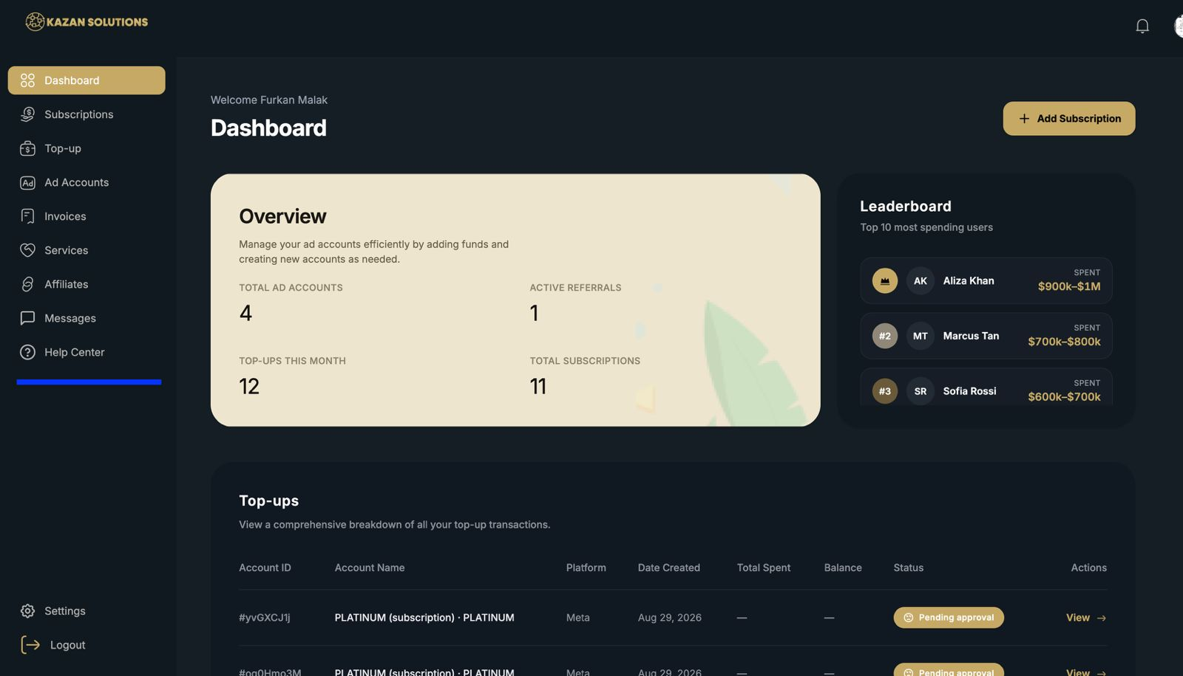
And on the client his side he should have a section called ‘’Manage Orders''

Where he can manage his subscription to cancel, where he can put a complaint about the service and that it will redirect to messages so our team can solve it and where he can click on ‘’Great job’’ it means the order is delivered successfully. Also he can see that his order is in pending when it's delivered he gets a notification with ‘Hi friend, your (service) is delivered!'

Make also in his manage orders a smile count check the picture here below

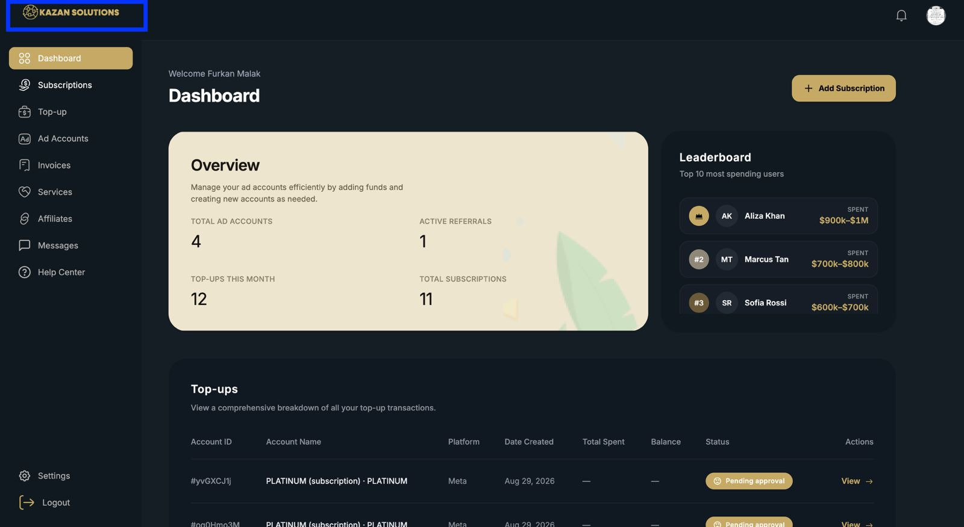When they click on the logo they will redirect to the dashboard section.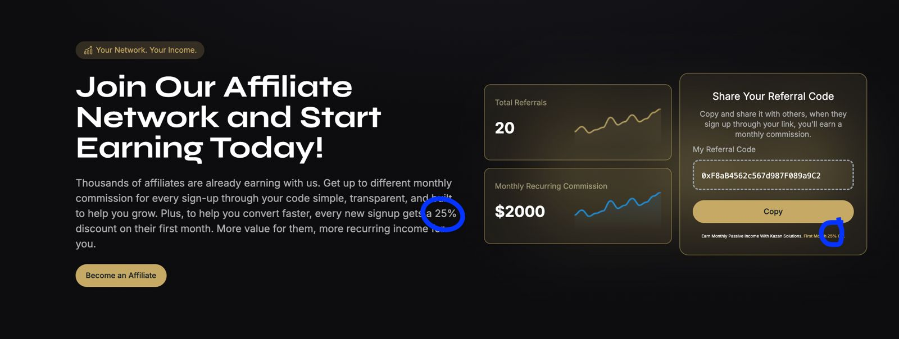Make this 10%

Also instead of say Thousands of affiliates make it Hundreds. (begin of the text)
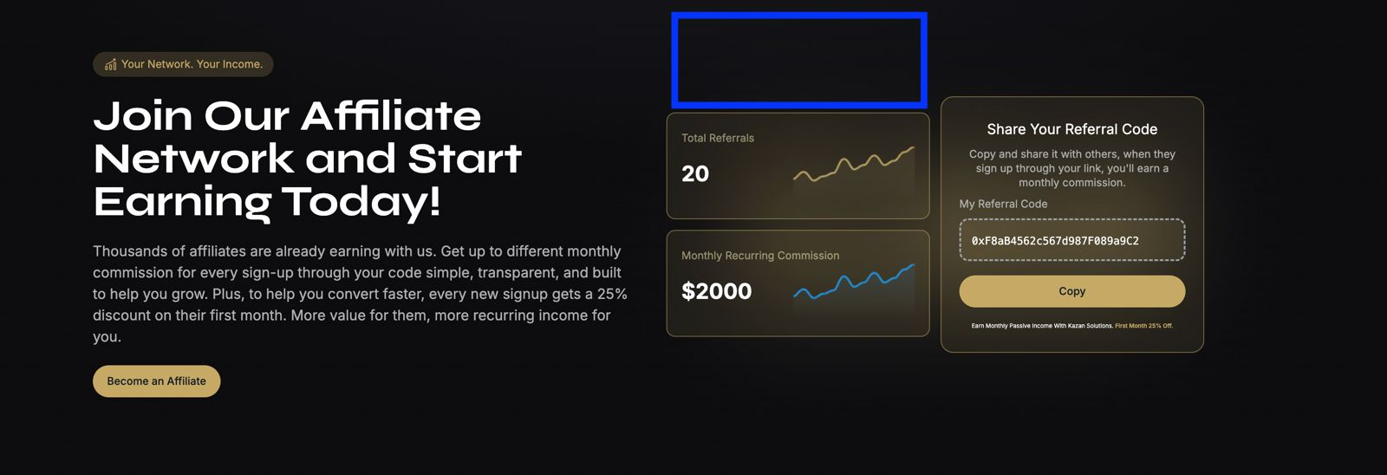Add a new thing with

Earn 15% of monthly fees passively.

Make this text big ^

$17.470 <- Make this big as well
‘’Reclaim your money’’

Options: Crypto & Top-up your ad-account or Sent to bank.
